**User Interface Design and Implementation**

Final Report (April 2017)

|  |
| --- |
| Maximizing learnability and user satisfaction through integrated and streamlined interface for information overloaded website |

Chiew Jun Hao (1001046)

Gao Xiongyi (1000894)

Tan Yi Hui Valerie (1001191)

Wang Yujia (1000911)

Zhang Zhexian (1001214)

Singapore University of Technology and Design

Table of Content

**1. Abstract** **7**

**2. Introduction** **8**

2.1 Background 8

2.2 Problem Statement 8

2.3 Main Strategy 8

**3. Target User Issues** **9**

**4. Literature Review** **10**

4.1 Existing Products that Alleviate the Pain of Filling up Forms 10

4.1.1 Dashlane 10

4.1.2 Telecommunication Services 11

4.2 Gamification 12

4.2.1 LinkedIn 13

4.2.2 Edmodo 14

4.3 Navigation system and visual elements 15

4.3.1 Visual Element Arrangement 15

4.3.2 Usability of Navigation Tools 15

4.4 Exploratory search 17

4.5 Existing websites and services with helpful navigation solutions 19

**5. Design Exploration** **20**

5.1 Design Overview 20

5.2 Project Timeline 22

5.3 Questionnaire 23

5.3.1 Stage 1: Questionnaire Draft in Word Document 24

Design Summary: 24

Design Concepts Used: 24

Heuristic Inspection: 24

User Feedback: 25

5.3.2 Stage 2: Mock up of Questionnaire UI 25

Design Summary: 26

Design Concepts Used: 26

Heuristic Inspection: 26

5.3.3 Stage 3: Questionnaire Prototype on Wix 27

Design Summary: 27

Design Concepts Used: 27

Heuristic Inspection: 28

User Feedback: 28

5.3.4 Stage 4: HTML-based fully functioning UI Prototype 29

Design Summary: 29

Design Concepts Used: 30

Heuristic Inspection: 30

5.3.5 Stage 5: HTML-based fully functioning UI Prototype (improved version) 30

Design Summary: 30

Design Concepts Used: 31

5.4 Card Comparison 31

5.4.1 Stage 1: Validation of Concept (Powerpoint) 31

Design Summary: 31

Design Concepts Used: 32

Heuristic Inspection: 32

5.4.2 Stage 2: Improvement of User Interface (Wix + HTML) 32

Design Summary: 33

Design Concepts Used: 33

User Feedback: 33

Heuristic Inspection: 34

5.4.3 Stage 3: Working Product implemented for User Testing (HTML) 34

Design Summary: 35

Design Concepts Used: 35

User Feedback: (Future Improvements) 35

5.5 Card Application 35

5.5.1 Stage 1: Initial mockup for Card Application 35

Design Summary: 35

Design Concepts Used: 36

User Feedback: 36

5.5.2 Stage 2: Mock up of Application UI 36

Design Summary: 37

Design Concepts Used: 37

Heuristic Inspection: 37

5.5.3 Stage 3: Functional Application Prototype (first version) 38

Design Summary: 38

User Feedback: 38

5.5.4 Stage 4: Functional Application Prototype (improved version) 39

Design Summary: 39

Design Concepts Used: 39

5.6 Card Details page 40

5.6.1 Stage 1: Identifying Problems and Comparing with Tabular Aspects 40

Design Summary: 40

Design Concepts Used: 41

User Feedback: 41

5.6.2 Stage 2: Card details prototype in Wix 42

Design Summary: 42

Design Concepts Used: 42

**6. Evaluation** **43**

6.1 User Testing 43

6.1.1 Design 43

6.1.2 Participants 43

6.1.3 Materials 44

6.1.4 Procedure 45

6.1.5 Result 45

Duration 46

Number of Card Details Viewed 47

User Errors 47

6.2 User Feedback 48

6.2.1 Design 48

6.2.2 Participants 49

6.2.3 Materials & Procedure 49

6.2.4 Result 49

6.3 Result Interpretation 53

6.3.1 Time Efficiency 53

6.3.2 Information Organization 53

6.3.3 Clarity and Mastery 53

6.3.4 User Satisfaction 54

6.3.5 Special Observations 54

**7. Impact** **55**

**8. Conclusion** **56**

8.1 Future Work 56

8.1.2 Improvements: 56

8.1.3 Other ideas: 56

8.2 Application to other domain areas 57

Web Services: 57

E-commerce apps 57

Supermarket Applications: recommend brands of product to buy given the budget constraints and quality requirements (e.g. toilet paper rolls) 57

Daily Products: 57

Education / Psychology: 57

8.2.1 Visa Application: 58

8.2.2 TV Example: 59

8.2.3 Restaurant Booking App: 60

Inspiration: 60

8.3 Concluding statement 61

**References** **62**

**Appendix** **62**

Appendix A- Card Comparison Page: Design Exploration Details 63

Iteration 1 63

Iteration 2 64

Iteration 3 65

Iteration 4 66

Iteration 5 67

Iteration 6 68

Iteration 7 69

Appendix B- User Testing Scenario 71

Scenario 1 71

Scenario 2 72

Appendix C- Screen Recording Analysis Raw Data 73

Appendix D- Questionnaire (Post-testing) 75

Appendix E- HTML Code 80

# 

# 

# 1. Abstract

“Information overload” is a term we have used to encapsulate the difficulty of understanding an issue, thus unable to effectively making decisions when too much information is available. We observe information overloading especially for Internet-aided services such as online immigration application, web-based insurance claiming and Internet banking. The service interface is complex and disorganized.

This project focuses on reducing information overload present in Internet banking services. Specifically, we aim to redesign the DBS credit card application website for computer-literate users. We reconstruct the linear website flow into an integrated structure by separating it into four steps: questionnaire, card recommendation, card information, and application. Using streamline and adhering to UI guidelines, we aim to increase user satisfaction and learnability, as well as create an optimal organisation of credit card details and intuitive and engaging credit card selection and application flow.

Our iterative design implementation involves both the study of existing solutions and research papers, heuristic inspection, user feedback and lastly, user testing of our prototypes.

The user testing results have shown that our design reduces total application time and improves information clarity. User satisfaction is also increased.

In addition to banking services, our information organization and workflow design may also be applied to other areas where information overloading poses a problem for users.

# 

# 

# 2. Introduction

## 2. 1 Background

The overarching problem of the project revolves around the difficulties arising from information overload which is pervasive in this world.Information overload is a process where immense data debilitates a user from making an informed decision quickly. Professor Levitin at McGill University remarked that “we have created more information in the last 10 years than in all of human history. All of this is more that what the brain is configured to handle… beyond that, you begin to exercise poorer judgement.”3

This trend will continue to persist in the foreseeable future. Combined with the endless stream of web services like E-commerce products and Internet banking services, the conventional user interface needs to evolve in order to cope with this change. Among different industries and sectors, the banking industry-- specifically consumer credit card application, was chosen for this project due to its information complexities, application tediousness, and relevance to our everyday life.

## 2.2 Problem Statement

Internet Banking websites like DBS.com.sg is overloaded with details about their long list of products and services. Users with no domain knowledge may find it hard to understand the information, preventing them from arriving at a fully informed decision easily. For instance, many customers are having difficulties finding the bank card that suits them the best. This is likely a result of foreign terminologies used, such as credit, debit, or brand-specific terms such as ‘Frank card’, ‘Everyday card’, etc.

Our project aims to design a streamlined and gamified credit card application process, in the form of desktop-based website, targeting users with limited domain knowledge, thus maximising learnability and user satisfaction.

## 2.3 Main Strategy

We used an iterative approach in developing the User Interface (UI) prototypes. At each steps of the design, we conducted user feedback and heuristic inspection to examine if our design complies with the UI guidelines and principles. When there are more than one design ideas, multiple prototypes would be created to gather user feedback on choosing the better strategy. In addition, streamlining and gamification techniques were applied extensively in the project to filter information and ease the tedium of filling up forms.

# 3. Target User Issues

Potentially, our project could target the issues faced by both computer literates and expert users, whose characteristics are explained below:

**Table 3.1** Target User Issues and Objectives

|  |  |  |
| --- | --- | --- |
| **Target User** | **Characteristics** | |
| Before (Existing Issues) | After (Objectives) |
| Computer Literates | 1. Lack of domain knowledge and experience 2. Confused about terminologies | 1. Complete user guidance and recommendation system 2. help user to understand terminologies and pick the suitable product or service. |
| Expert Users | 1. Hindered by poor navigation | 1. Streamlined process and clear navigation 2. Directly find specific product or service |

**Table 3.2** Target User Groups Analysis

|  |  |  |
| --- | --- | --- |
| **Target User** | **Computer Literate** | **Expert User** |
| Computer skill | Good | Good |
| Knowledge on the app | Neutral | Neutral |
| Domain knowledge | Poor | Good |
| Time | Sufficient | Lack of time |

For the first type of users (Computer Literate), they may only have a vague idea about the product, but lack comprehensive domain knowledge. They might be confused by the various complicated terminologies for bank card applications. Therefore, we could provide well-designed user guidance and recommendation systems, that can help direct those users to find their suitable products or services.

For the second type of users (Expert Users), they are professional in this domain and seek for a specific product. However, their search process may be hindered by the poor navigation system. Due to time constraint in this project, expert users are not our target user. However, future explorations can be done to simplify search process for them.

# 4. Literature Review

## 4.1 Existing Products that Alleviate the Pain of Filling up Forms

### 4.1.1 Dashlane

The most prevalent autocomplete product in the market is Dashlane. Below is a diagram of how Dashlane works:



**Figure 4.1.1.1** Operation of Dashlane

The lighter the colour, the less number of fields a user has to manually fill up. The fields are reduced each time new data is registered in the Dashlane database. As shown in the figure below, an impala icon will appear in the textbox if a user has filled in this information before in other applications. Clicking the icon would trigger Dashlane to automatically fill up for the user.

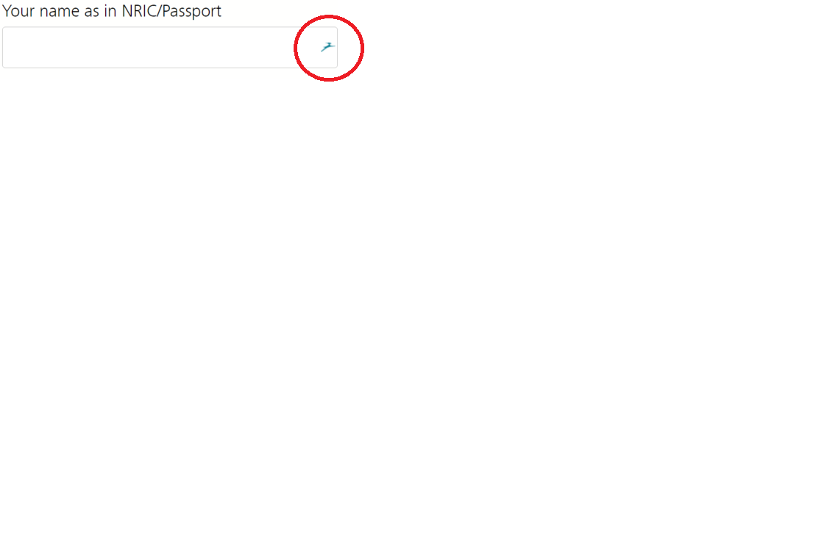

**Figure 4.1.1.2** An impala icon will appear if the textbox requires information found in Dashlane database

**Advantages**

We have tested this product for a week and it has been proven to be useful in filling up application forms on desktop. The system auto-detects the input fields in an application form. At the click of an icon, text boxes will be filled with my details.

**Disadvantages**

However, it gets irritating every time a prompt appears after logging into applications such as student email. The amount of time wasted on closing these prompt surpass the time saved by using Dashlane.

### 4.1.2 Telecommunication Services

Telecommunication company Singtel’s prepaid card top up website has a clear flow of information. The UI is straight-forward and guided. Below is a snapshot of an example page.

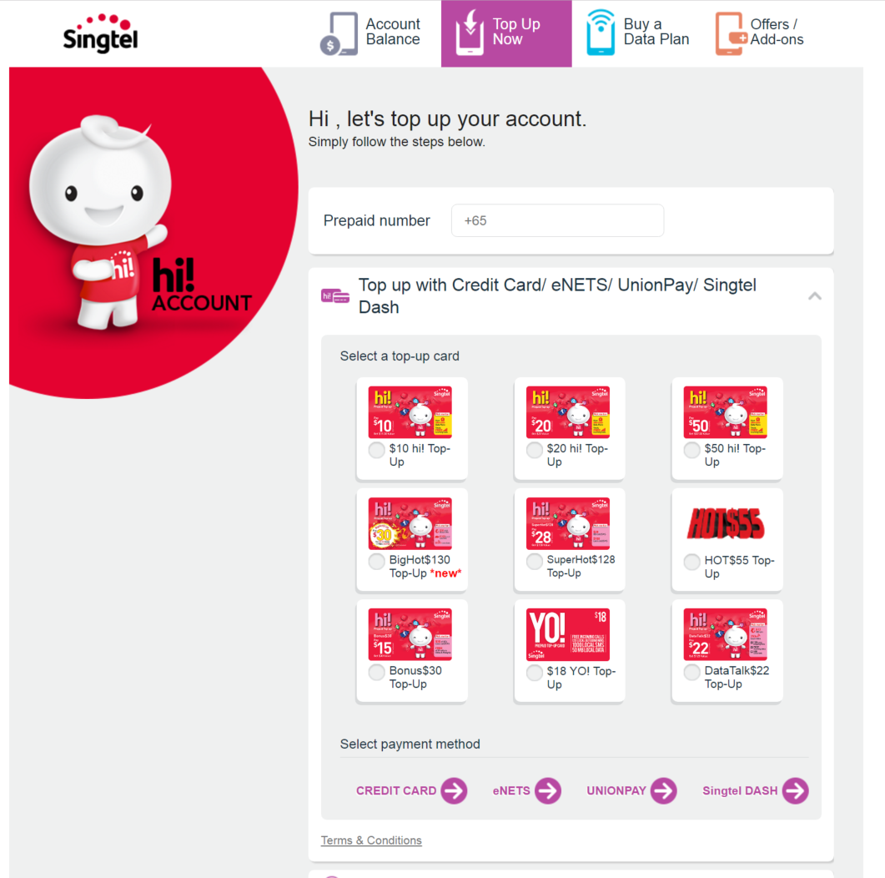

**Fig 4.1.2.1** Prepaid top-up page

The process is guided vertically.At the top, there are services classified into tabs, below which is the fields for entering prepaid number, the package you may want to purchase, and then payment method. The user does not need to worry about other information that is not essential for top-up. When a section is completed, the website will automatically draw user’s attention to the next section. With all the graphical and iconic design, the user would not be likely to feel the process long or tiring either.

## 4. 2 Gamification

A saying goes that “gamifying process is nothing but a really effective means of communication and education”. Our team explored websites that utilises gamification successfully to motivate users to complete their profile details. Some of the websites we studied include LinkedIn and Khan Academy.

### 4.2.1 LinkedIn

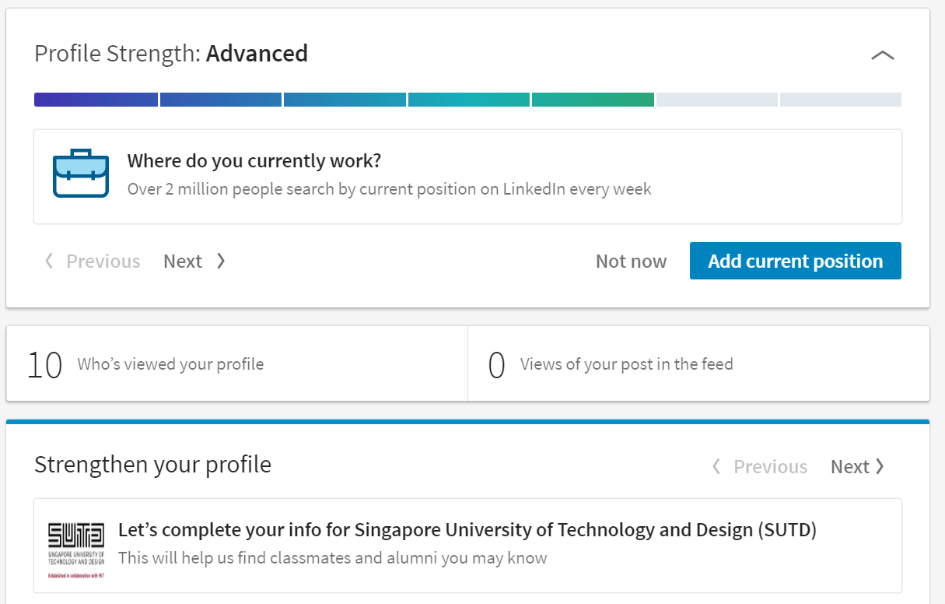 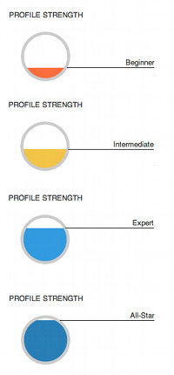

**Fig 4.2.1.1** LinkedIn’s gamified user interface

LinkedIn uses a graphical approach, such as showing profile strength bar, to motivate user to fill up useful details about themselves in their profile page. In the figure above, profile strength is indicated as advanced, with two empty progress bar to motivate the user to push a little further to perfect their ‘stats’. In previous version, it was displayed as a partially filled circle. Below it, is a specific question which allows user to strengthen their profile. In this case user is provided with a tangible method to strengthen their profile.

### 4.2.2 Edmodo

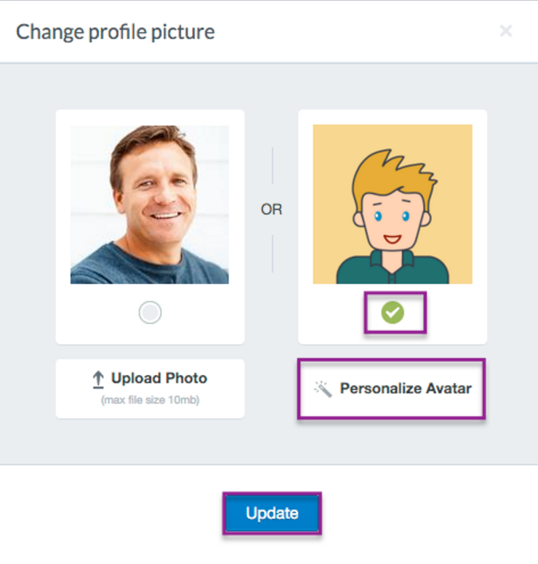

**Fig 4.2.2.1** Creating Avatar in Edmodo

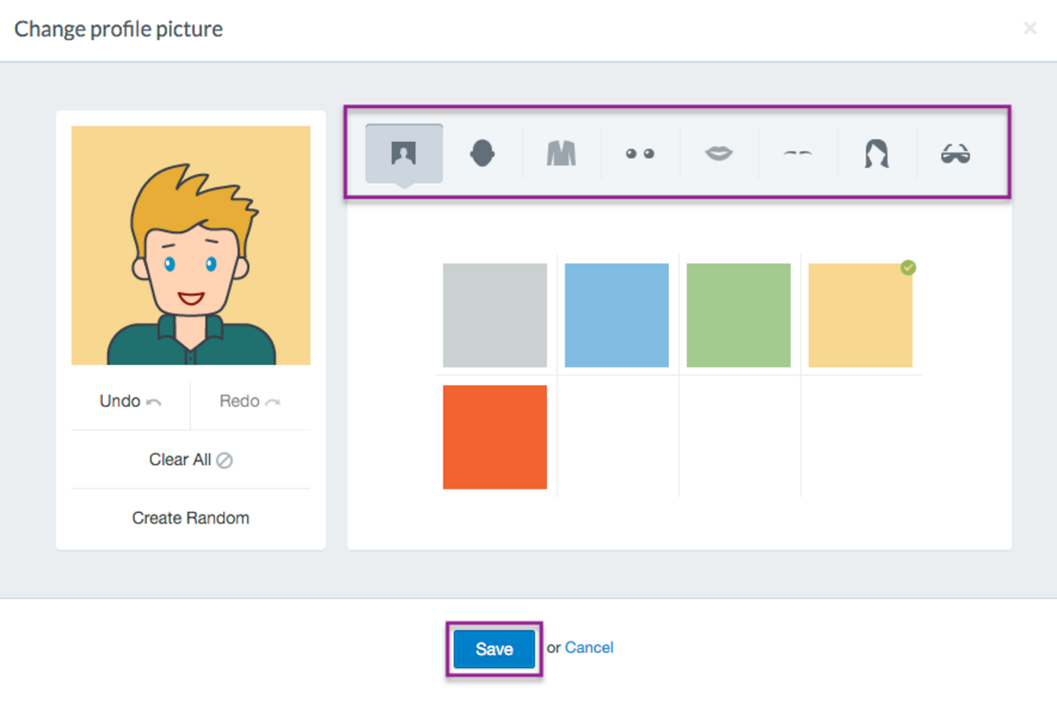

**Fig 4.2.2.2** Customising Avatar in Edmodo1

Edu Tech giant, Edmodo, utilises avatar creation and customisation to encourage participation and networking between users. We created a similar UI for the questionnaire launched at the start of our website. The purpose is to inject the fun element and a sense of progression as the user fill up the questions. This would effectively reduce the boredom of user filling up forms and questionnaires.

## 4.3 Navigation system and visual elements

### 4.3.1 Visual Element Arrangement

We examined a research on Visual Elements of Web UI design by Liu and Ma 2, discussing the importance of visual elements’ arrangement in the web UI design process. It raises the point that visual process forms the path of the visual flow,which is influenced by mass media restrictions and user habits of user. There are three different kinds of visual flow paths, which are smooth, regular and ordered curves. Majority users smooth curves. Different examples of smooth curves are shown below:

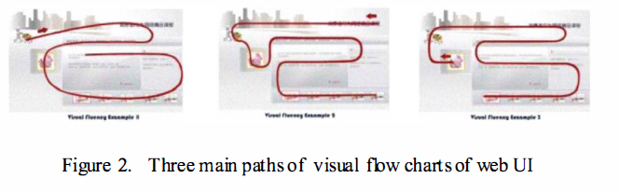

**Figure 4.3.1.1** Different visual flow paths

Based on this study, we are aware that with regards to webpage UI design, the content layout and structure should create a smooth visual path that does not violate visitor’s visual habit. In addition, a webpage’s content should be placed in the focal point of a user’s field of view, the first thing the user see when she visits the site

### 4.3.2 Usability of Navigation Tools

This research paper investigates the usability of navigation tools for browsing genetic sequences. There are huge amount of data to deal with when facing DNA sequences, and software used in displaying DNA sequences are crucial for bioinformatics research. The current tools do not provide explicit feedback or information to the user, as to whether they are heading in the right direction. This causes the user to ‘get lost’ in the huge pool of sequences 6.

This research paper provided us with various options of implementing the navigational feature in a software and also examples in conducting a heuristic evaluation of user interface controls. One way of designing navigational feature is to compare the existing tools used for navigating in a page. The next two figures illustrate the consideration of the researchers and an example of a prototype aimed at empowering users in panning across the DNA sequences.

**Fig 4.3.2.1** Comparison Table for existing Tools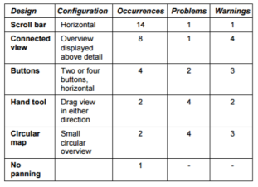

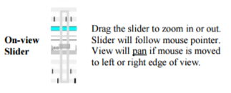

**Fig 4.3.2.2** On-View Slider created by researchers to facilitate 2 Degree of Freedom Navigation in a page

For user-testing side, the paper provided a useful graph to evaluate the effectiveness of the newly implemented UI. We intend to use this for our user testing to evaluate our UI.

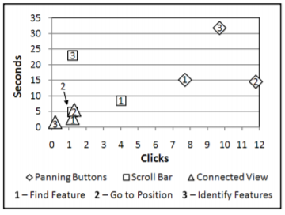

**Fig 4.3.2.3** Average Number of Seconds and Clicks for Planning Tasks

## 4.4 Exploratory search

Wu and Turpin’s research presents query aspects of support exploratory search11. When a user wants to know more about the details for credit cards, they will use Google to search and compare what the different banks have to offer. Current word-based search engines are useful in homepage finding, however, when it comes to deep exploratory search task like topic learning, it is not very useful. The researchers aim to overcome this limitation by capturing the search journeys of other users with semantically related searches, and use them as roadmaps to guide users in their topic learning.

So far, we have learnt from the paper two things -- how search results are diversified, and how they created a new interface to facilitate the exploratory search.

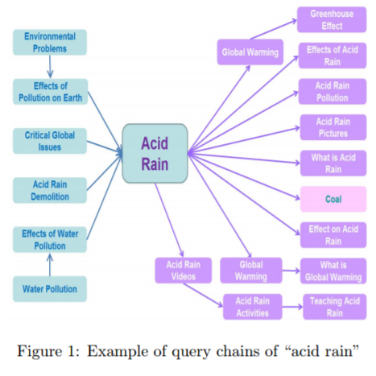

**Fig 4.4.1** A query chains of “Acid Rain”

From the above diagram, we can see each chain reflects a particular aspect of Acid Rain, for instance, how water pollution is a result of acid rain and how acid rain is related to global warming.

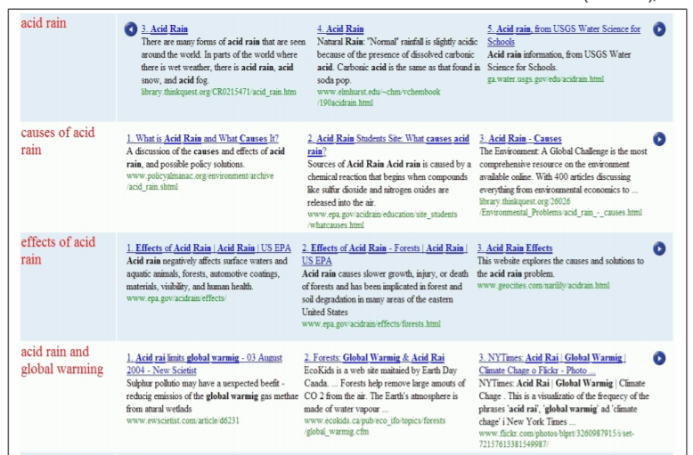

**Fig 4.4.2**  Tabular Aspect Interface

The tabular aspect interface presents a list of useful queries of “Acid Rain”. Each row presents an aspect of acid rain, and each column presents the rank of the pages based on their coverage of the keywords. This is extremely useful as it saves the user time and energy, since reformulating their search queries is time-consuming. On top of that, most of the useful information is consolidated succinctly under one page.

Of course, we are not building a search engine. The concept of query chains can help us generate a highly diverse path for our UI, thereby creating a more satisfying user experience.

We have modified this concept in designing the page for card details where user want to find out more about the card. In our card details page, tabular aspect is displayed vertically, so user scroll in the most intuitive way to understand the different aspect of the credit card.

## 

## 

## 4.5 Existing websites and services with helpful navigation solutions

Our team have found and consolidated websites with UI features we can use for our UI design. These websites served as an inspiration during ideation phase.

**Table 4.5.1** Summary of Good Navigation Solutions

|  |  |  |
| --- | --- | --- |
| **Name** | **Strengths/Solutions we want** | **URL** |
| SUTD website | Classifies information into undergraduate/phd/prof etc | <http://www.sutd.edu.sg/> |
| ICA | 1. The categories of users are immediately displayed on the home page, with the most common functions listed. 2. The frequently accessed e-Services are displayed on the right. | <https://www.ica.gov.sg/> |
| Phone topup  (e.g. SingTel / M1) | 1. Step by step instructions 2. Not showing unnecessary info 3. Use of images and icons 4. Consistent color scheme | <https://hi.singtel.com/gotoTopUp.do> |
| Electronic Product Service | 1. Sorted by product, then further categorised by problem 2. Use of image and icons | Apple <https://support.apple.com/en-sg>  Toshiba  <http://www.therepairhospital.com/toshiba-laptop-repair.htm> |
| NTUC Insurance claim | 1. Clearly numbered steps 2. Expandable instruction items 3. Big icons and instructions with ample white space breather | <http://www.income.com.sg/claims> |
| Job Search | Questionnaire dropdown provides guidance and reduces memory load | <https://www.jobsbank.gov.sg/> |

# 5. Design Exploration

## 5.1 Design Overview

Frustrated by the complicated steps and terminologies used during bank card applications, we inspire to create a better web interface design to help computer literates make more informed decisions without overload them with information. Improving user satisfaction and learnability is our primary goal. After extensive research, we decided to increase user satisfaction using streamline UX design technique.

**Streamline**: To improve the efficiency of a process, business or organization by simplifying or eliminating unnecessary steps, using modernizing techniques, or taking other approaches. 8

In other words, a streamlined UI is one where every process and elements are located exactly where the user wants it, and is not visible when the user does not require it 9. Moreover, we incorporate other methods such as gamification design.

**Gamification**: Gamification is the process of taking something that already exists and integrating game mechanics into it to motivate participation, engagement, and loyalty. Gamification takes the data-driven techniques that game designers use to engage players, and applies them to non-game experiences to motivate actions that add value to the application.10

We also ensure that we adhere to UI guidelines to further improve user satisfaction and increase the learnability of the website.

We analyzed the current flow of DBS website as shown in Figure 5.1.1. It is a linear design flow where the user starts from a main page listing all the cards, afterwards viewing card details, and finally apply for bank cards. However, users are overwhelmed with the amount of information thrown to them on the main page, that they have to view many additional card detail pages to select the right bank card. Terminologies are not explained properly at the card details page, resulting additional researches. Lastly, the application steps are lengthy and tedious.

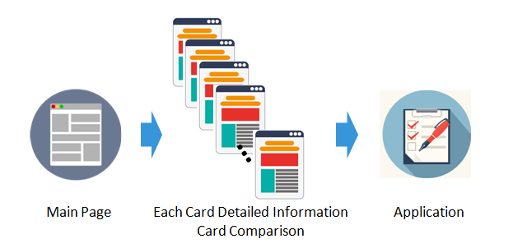

**Figure 5.1.1** Current system flow

We believe the DBS website could be better designed by streamlining the process, modifying from its linear structure. As shown in Figure 5.1.2, our final website design fully utilizes every information the user entered during each process and reduce the repetitive information required from them. There are four main steps:

1. **Questionnaire:** The questionnaire aims to gather basic information from the user. It serves as a foundation for later steps.
2. **Bank Card Recommendation:** Bank cards will be selected based on questionnaire results. it will recommend the top 3 cards and eliminate the non-eligible cards from the results page. The amount of information shown to user is significantly reduced as compared to the original DBS website.
3. **Card Details and Comparison:** With the previous card recommendation step, the number of card details viewed by the user will decrease. Also, with exploratory-search design, computer literates with little financial knowledge can understand the terms and conditions easily. Meanwhile, we offer the card comparison function. The initial comparison criteria will be based on questionnaire answers, and the default cards to compare would be the recommended cards. Better UI and functionality design enables user to customize the set of comparison criterias relevant to them, and rank cards for each criteria.
4. **Application:** The user can apply up to 3 cards at once. The application is pre-filled with information from the questionnaire. This reduces the application time significantly and increases user satisfaction.

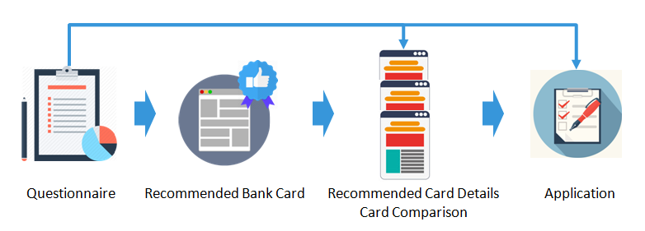**Figure 5.1.2** Our System Flow

In addition, design guidelines such as consistency, reduction of user’s memory load, and provide easy reversal of actions were constantly implemented and inspected. We also adopted the gamification idea to make the process more interesting. Detailed design exploration for each step will be presented in the next section.

## 5.2 Project Timeline

A brief summary of the project timeline is shown below, each stage represents a major milestone in our prototype. Besides the final usability testing during week 12, we did multiple heuristic inspection and user feedback after designing each prototype. The detailed design of each stage will be illustrated in the following sections.

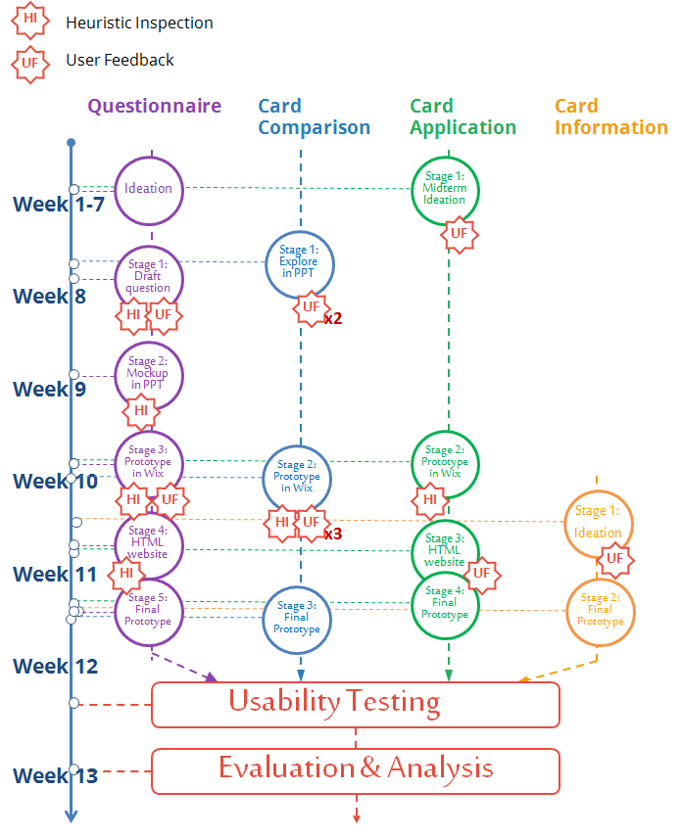

## 5.3 Questionnaire

The questionnaire UI design has gone through five major prototyping stages. At the end of each stage, we did a heuristic inspection and/or usability testing to validate our ideas and make further improvements.

### 5.3.1 Stage 1: Questionnaire Draft in Word Document

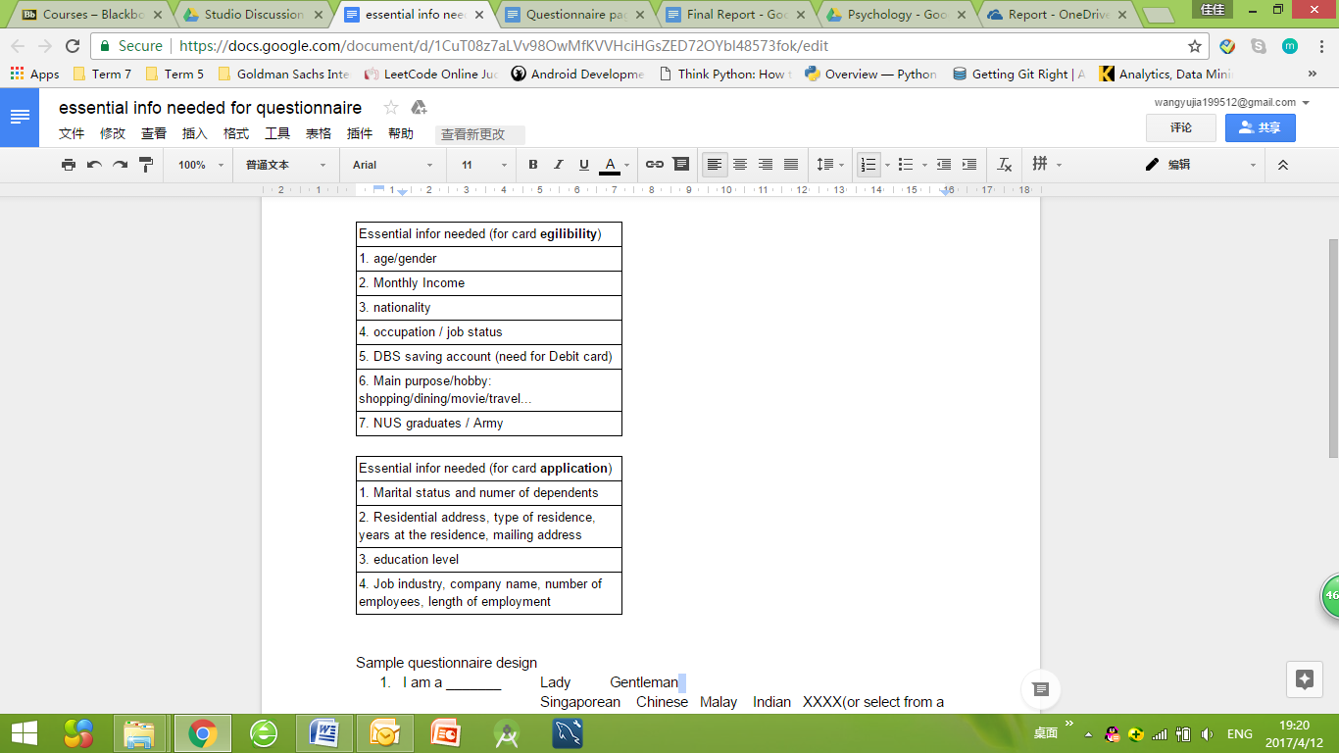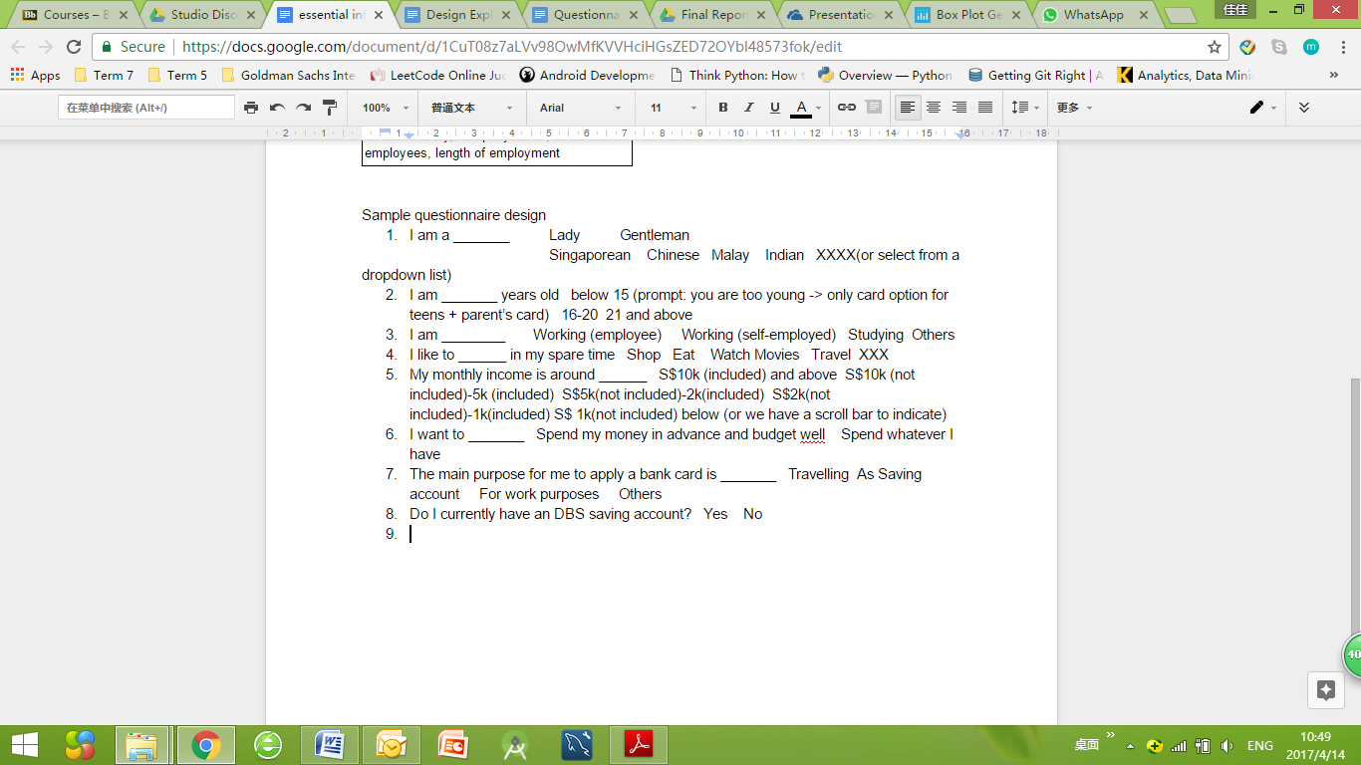

**Figure 5.3.1.1** Questionnaire Draft in Word Document

#### Design Summary:

In the first stage of prototyping, we listed down all the essential information needed for card filtering and application. Those information were gathered based on our previous research on DBS website. Afterwards, we selected the non-sensitive information and wrote the first version of questionnaire. It contains 8 questions, all of them are multiple choice questions.

#### Design Concepts Used:

We followed the **questionnaire design techniques** as taught in class. All multiple choice questions have closed range of answers. We started from general questions like gender, nationality before going to more specific questions such as income range, expense habit etc. In addition, for the income range question, we used ‘included’ and ‘not included’ to avoid overlapping in scale: S$10k (not included) to S$5k (included).

#### Heuristic Inspection:

The main purpose for this heuristic inspection is to find out whether the length of questionnaire is appropriate. We asked each group member to complete the questionnaire and sought their feedback. All members in the group took part in the heuristic inspection. It took them on average about 30 seconds to complete the questionnaire.

Surprisingly, it turned out that the length of questionnaire was considered were considered short based on feedback. So in the second version, we expanded the number of question from 8 to 12, as it would help us get more information and filter more cards for the user.

#### User Feedback:

We conducted an informal user testing to find out if the user is comfortable with the type of question asked in the questionnaire. Three users were asked to complete the questionnaire and provide their feedback. Two of them were satisfied with the questionnaire, both its length and the type of questions asked. However, one user said that he felt uncomfortable revealing his monthly income and highest education level. He thought they were too personal.

Monthly income is an important criteria in filtering our non-eligible bank cards for users. Some bank cards requires the applicant to have a minimum salary. In addition, the questionnaire only asked for a range instead of specific numbers. Similar reasoning with highest education level. Therefore, we decided to keep the the questions, at the same time making all of them optional so that the user can skip whenever he or she feels uncomfortable.

### 5.3.2 Stage 2: Mock up of Questionnaire UI

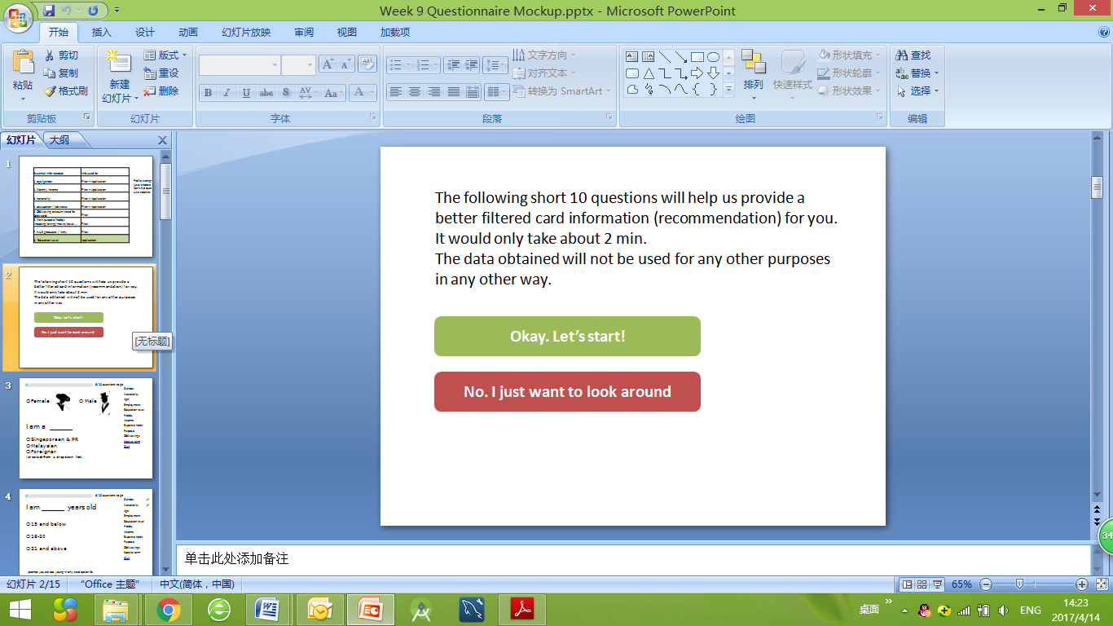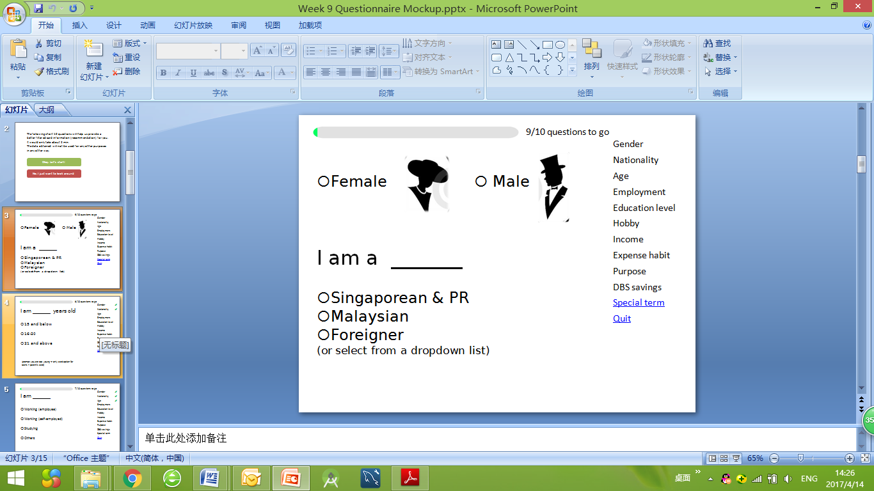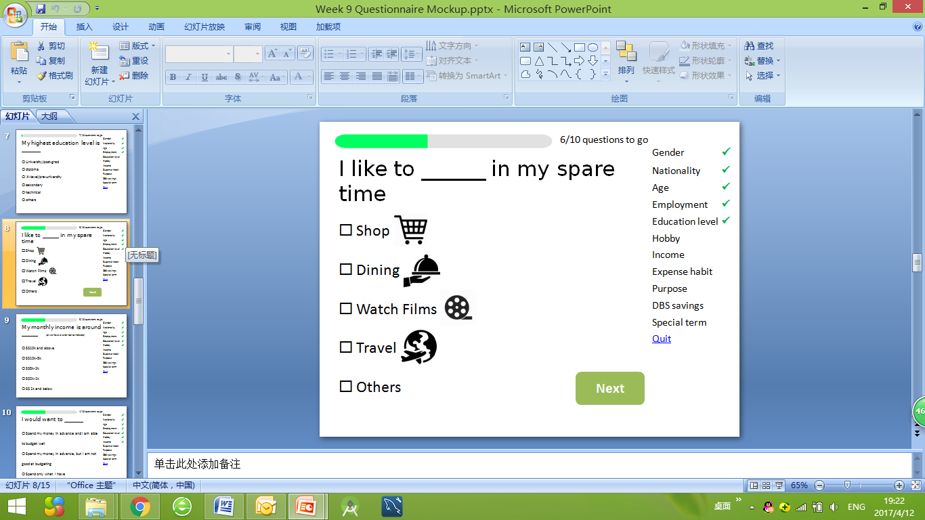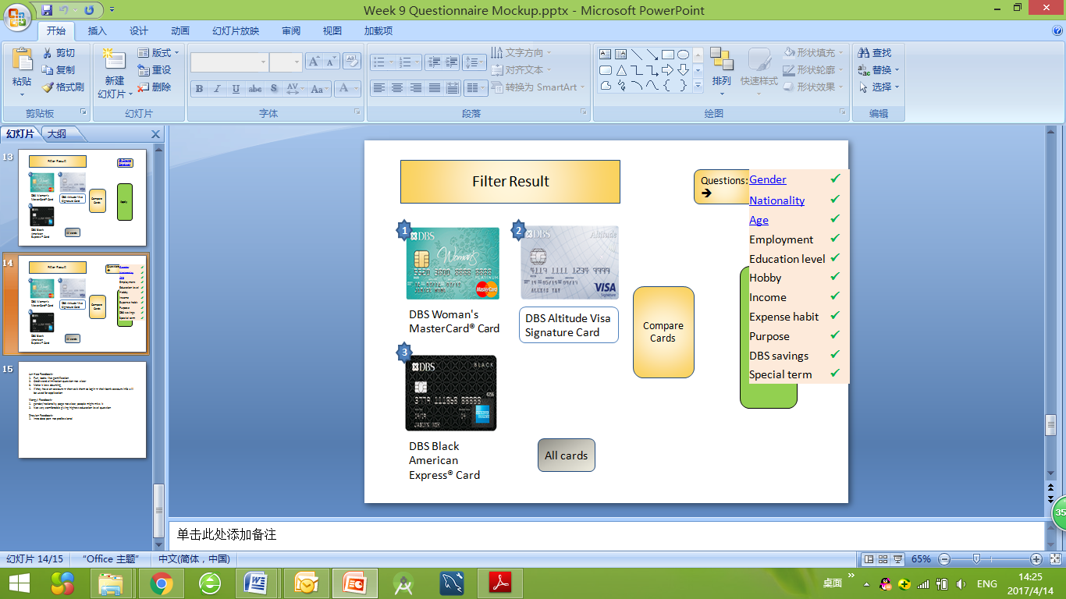

**Figure 5.3.2.1** Mockup of Questionnaire UI

#### Design Summary:

We used Powerpoint to make an animated mockup in this version. The main purpose was to explore different user interface designs, and to find out how it could be integrated into the overall flow.

First of all, the user could choose to complete the questionnaire or view all cards directly. A progress bar would indicate the level of completion. On the right side there is a list all the questions, so the users could skip any question if it is too personal. For each question answered, there will be a tick on the list. We hope this would encourage the users to complete all questions. We use infographic to make the questionnaire less boring. Images were used whenever possible to replace lengthy words. After the user completes the questionnaire, a filtered result page will be shown. However, the user can go back to the questionnaire to change the answers by clicking on ‘change answers’ button.

#### Design Concepts Used:

In order to **prevent user-driven errors**, we used circular or square boxes to indicate if the question requires a single answer or if multiple answers are allowed. If the user can only choose one answer, the page will automatically scroll to the next question. If multiple answers are allow, a ‘next’ button will be shown.

We provide **easy reversal of actions**. For example, the user can click any question in the list on the right side of screen. Then he or she will be able to change the answers. In addition, we provide the ‘change answers’ option in the filtered result page, so the user would easily go back to the questionnaire.

**Affordance** is maximized as far as possible in the prototype as well. We distinguished buttons and texts, clickable or non-clickable with the use of different colors and underlines.

#### Heuristic Inspection:

To further improve the user interface, we did a heuristic inspection within the group. Each group member was asked to complete the questionnaire and provide feedbacks. Some mentioned that the introduction part is not professionally phrased and styling was inconsistent. The first question which asked about gender is not presented obviously, that an user may miss it. One suggested that it would be better to add more gamified elements. On average, our inspectors took about 1 minute to answer all the questions.

Based on the feedback, several design principles would be used to improve the UI. First, we should improve the consistency of the layout, that the buttons should be in the same color and format as current DBS website. Though using graphics is nice, overly large pictures may distract users. Hence, we need to adjust the information/administration ratio. Furthermore, important information should be prioritized by adjusting the question sequence. We observed that users do not use the question list on the right, thus this feature may be considered underused and may be removed. Lastly, we brainstormed gamification ideas and did literature reviews to further ease the burden of completing a questionnaire.

### 5.3.3 Stage 3: Questionnaire Prototype on Wix

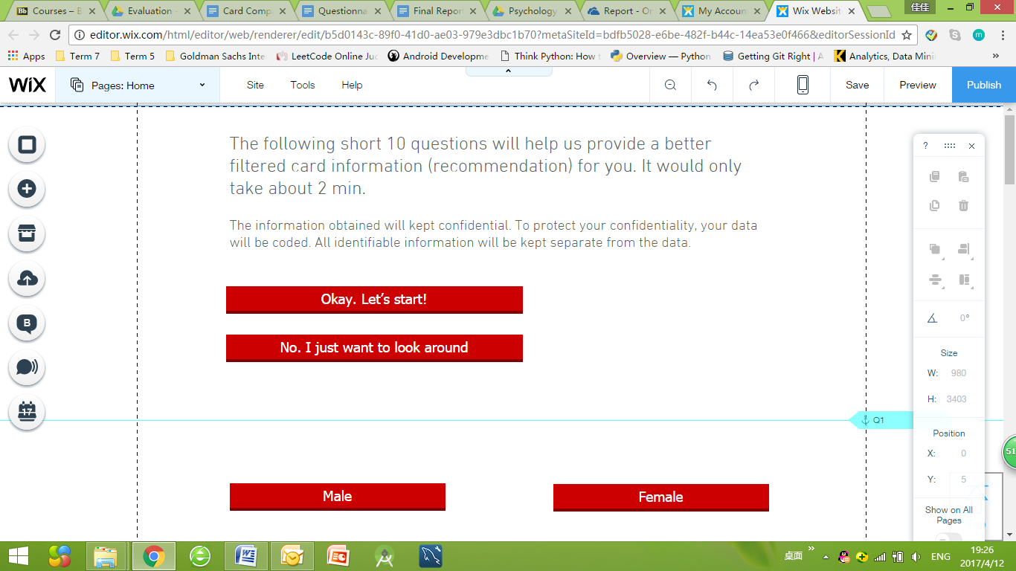

**Figure 5.3.3.1** Questionnaire Prototype on Wix *(the blue line indicates web page anchor we inserted for the scrolling effect)*

#### Design Summary:

After previous two rounds of mock ups, we integrated all parts of the design and created a formal prototype using Wix. We created a functioning prototype containing questionnaire, card filtering, and the application form.

In this version, we unified the UI styles and added the auto scrolling function, inspired by the Singtel’s top up page as mentioned in the literature review. When the user answer one question, the website will automatically scroll down to the next question. In addition, based on the previous feedback, we reduced the amount of graphic used and removed the question list.

#### Design Concepts Used:

**Consistency** is improved in this prototype. All the buttons are using current DBS style, which is the red color with dark red shadow.

Graphic design is reduced because we wanted to improve the **information to administration ratio**. However, at the same time, we want to make the questionnaire more engaging. These are two conflicting ideas which led us to explore gamification method.

Question list was intended to reduce user’s memory load. What we found out during last version was that people didn’t refer back to question list at all. It was mainly because the length of questionnaire is relatively short, having this extra information presented would make the UI looks clustered and impede user from answering the questions.

**Fitt’s Law** indicates that the *time it takes to click a button* is proportional to the *distance between cursor and button*. Providing the auto scrolling feature would significantly reduce the amount of time a user takes to complete the questionnaire by indirectly reducing the click distance. User satisfaction would be improved by applying Fitt’s Law.

#### Heuristic Inspection:

We invited our Professor and Teaching Assistant (TA) to join this round of heuristic inspection together with the group members. We aimed to find out any usability bug in the functionality of the features, such as if the UI is appealing and whether any design guidelines were violated.

One feedback from the TA was to delete the option of ‘No. I just want to look around’ because we would want to encourage the users to complete the questionnaire. Furthermore, feedback from the Professor was to fully utilize the information from the questionnaire in the card comparison page. More gamified version and clearer indication on multiple-answer questions were also brought up by group members.

Based on the suggestions, we removed the option of ‘No. I just want to look around’ and directly present the questionnaire with introduction. However, we provided the user with the freedom to see their questionnaire results at anytime. If they do not answer any questions, they would be directed to view all cards webpage. In addition, not only did we use the information gathered from the questionnaire to recommend cards and pre-fill application, we also use it to set the default card comparison criterias. For example, if the user indicate her hobby is dining, then the dining column will appear in the card comparison page by default. Lastly, we changed back the multiple choice style from red button to traditional circle and square boxes, in this way there would be a clear distinction between whether single answer or multiple answers is allowed.

#### User Feedback:

We did an informal user testing with some friends. We asked them to answer the questionnaire and provide their feedback. In general, they liked the idea of using questionnaire to help recommend cards. One user mentioned the red color scheme was not pretty, but we decided to keep it since it is consistent with DBS style. This colour consistency reduces the colour perception variable that may affect our evaluation result, so that any improvements in our UI is due to workflow design and information presentation, not due to colour scheme change.

### 5.3.4 Stage 4: HTML-based fully functioning UI Prototype

### 

**Figure 5.3.4.1** Questionnaire Prototype (HTML) Version 1

#### Design Summary:

After the previous prototypes, we did a fully functioning version using custom HTML code and Wix (please refer to Appendix E for the full HTML code). We replaced the ‘No. I just want to look around’ button with ‘See my recommendation result’ button, aimed to suggest the user to complete the questionnaire. Auto-scrolling down function is further improved in this version. For multiple answers question, such as hobbies, we indicated that using square boxes and providing ‘Next’ button.

#### Design Concepts Used:

**Consistency** is further scrutinized in this design. We align all the question, multiple choice and buttons. In addition, we only used two font sizes, one for question and the other for multiple choice.

#### Heuristic Inspection:

In this round of heuristic inspection, fewer problems were raised. We found out that the font may change depends on different screen size. So we adjust all font to fixed value. In addition, gamification ideas were brought up again. We need to add an interesting element in the questionnaire.

### 5.3.5 Stage 5: HTML-based fully functioning UI Prototype (improved version)

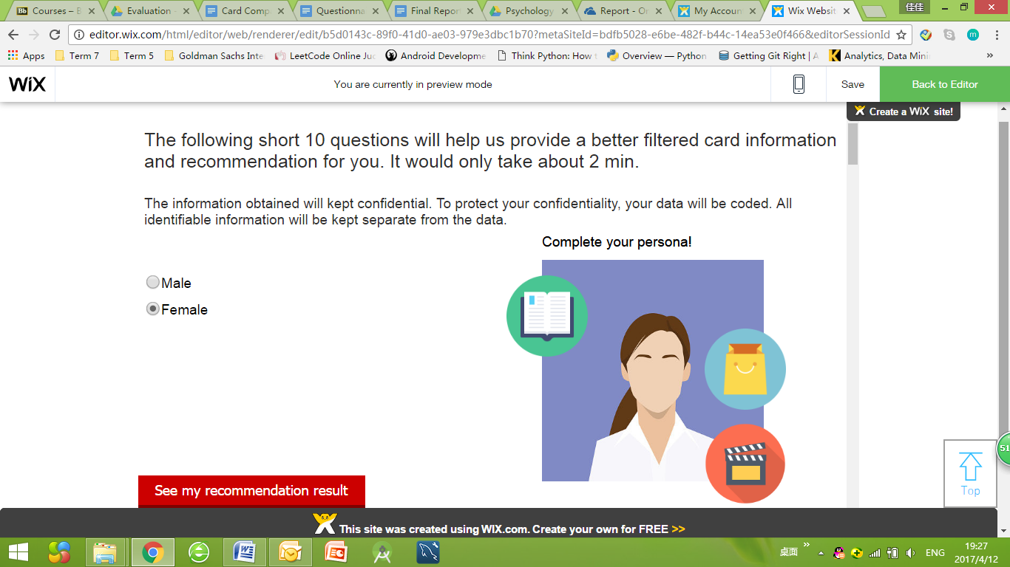

**Figure 5.3.5.1** Questionnaire Prototype(HTML) Version 2

#### Design Summary:

In this final design, gamification element is added. Adopting a similar approach as Edmodo mentioned in the literature review, we transformed a monotonous questionnaire into a small game of completing the user’s persona design. For example, when user indicates his or her gender, a male or female picture would show up. When the user choose his or her hobbies, corresponding icons will be displayed as well. This completion of persona game would motivate the user to keep answering the questions.

#### Design Concepts Used:

Different from Stage 2 mock up where we used infographic icons, this prototype uses **gamified design**. All the pictures are located in the right side of the screen, so that it will not block or distract user from reading the questions. In addition, this gamified version would increase the interactivity of the questionnaire.

## 5.4 Card Comparison

We have gone through seven iterations for this part of the design. Here, we only summarize the major milestones in the card comparison page. For more iteration details, user feedback and heuristic inspections, please refer to Appendix A.

### 5.4.1 Stage 1: Validation of Concept (Powerpoint)

Initial concepts were tested using prototypes made in Microsoft Powerpoint, with button hyperlinks used for transitions/animations.

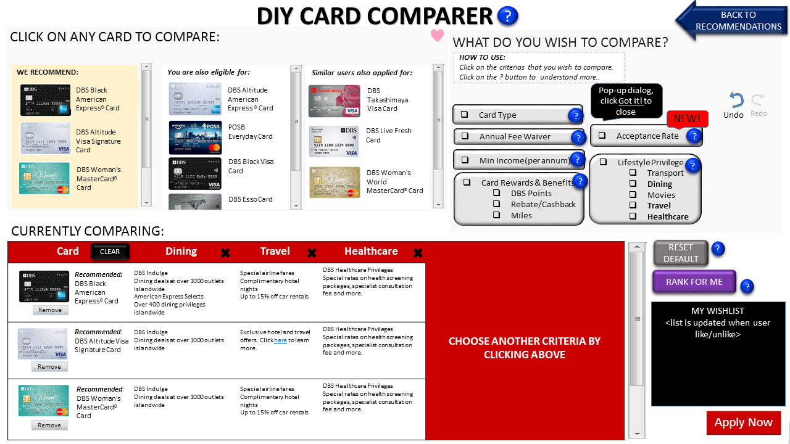

**Figure 5.4.1.1** Powerpoint Prototype-based Card Comparison

#### Design Summary:

In the first stage of our prototyping, we focused on validation of concepts, features and functionalities. The overall comparison process is as follows: the user can add multiple cards and select from various comparison categories to compare together in the comparison table. They can also remove categories as and when they wish. Brief explanations about comparison categories are provided, and displayed upon clicking of the question mark button. Cards that are “liked” will be added to the “Wish List” panel on the right.

#### Design Concepts Used:

Clear **grouping** of functions is applied: the cards and comparison categories to select are both placed on top, while the comparison table is placed below. Such grouping signals to the user what sequence of actions to take.

#### Heuristic Inspection:

With reference to the lecture slides, we discovered a few UI guideline violations. Firstly, there were too many unnecessary buttons/labels. For example, unnecessary features such as “Reset to default”. These issues have resulted in a **low information to administration ratio**. Also, the layout seems over cluttered and not streamlined -- the cards should be grouped together in 1 column to simplify the layout and make it less crowded. Finally, we realized that **clear mapping principle was missing**. The selection categories should have been placed directly next to their corresponding axis in the comparison table, so that the user can obtain clear feedback.

### 5.4.2 Stage 2: Improvement of User Interface (Wix + HTML)

#### 

**Figure 5.4.2.1** Wix + HTML Prototype -- Card Comparison

#### Design Summary:

In the intermediate stage of prototyping, we used Wix to create a more realistic-looking interface, and also embedded HTML code along the way. Here, we focused on layout and navigation gestures, iteratively improving them with each user feedback.

#### Design Concepts Used:

Based on the lecture slides, main principles applied included **alignment, grouping, mapping (for providing clear feedback), and sequence of action**. A balance of all these principles were considered to ensure that users are constrained in their actions, while also fulfilling the rule of “for every action, there is a reaction”, so that users can process the feedback easily.

#### User Feedback:

**Feedback Process:**

We showed the users the DIY Comparison Page layout, explained to them the purpose of this interface, asked them what are their thoughts about the different components in terms of placements, style, size, arrangement etc. In the process, we explained to them that this page is meant for comparing credit cards, and introduced the different sections.

The users were allowed to explore and give comments freely, and ask questions when they do not understand. Along the way, we recorded what users like or dislike. From there, we know what needs to be improved on, what has to be changed and what should be retained.

**Feedback Results:**

The major feedback we obtained from the user was regarding the layout sequence, that there was no **sequence of action**. In the initial designs , mapping principle was applied: the cards to select from were placed as a vertical column on the whole of the left side, while categories to choose from were placed on top of the comparison table. However, one user commented that the sequence of action was not clear, she did not know where to begin, i.e. if to select the cards first or choose comparison categories first. Hence, the comparison categories spanned the whole top part of the page (with Wishlist on the right), while the selection of cards and comparison table were both placed below. This way, the user is **constrained and directed** to start off by selecting comparison categories first. Thus, our solution aims to **balance** both **mapping** and **sequence of action.**

Other users commented on visual distractions(colour scheme) and navigation gestures (such as scrolling).

***Note:*** *Stage 2 iterative design is mainly focused on card comparison page, the card recommendation page was simply furnished with details to be put into working prototype.*

#### Heuristic Inspection:

Final adjustments were made before user testing was carried out.

The group gave feedback that the blue questions marks are distracting, and thus should be toned down; and the Wish List should be shown by default (not hidden) as it was not obvious that cards have been updated to the hidden Wish List. Overall, there were no major problems regarding the card comparison mechanism.

### 5.4.3 Stage 3: Working Product implemented for User Testing (HTML)

The final layout was designed after integrating all the feedbacks obtained from different layouts. The working product is coded using HTML , and some final amendments were made after heuristic inspection by the whole group.

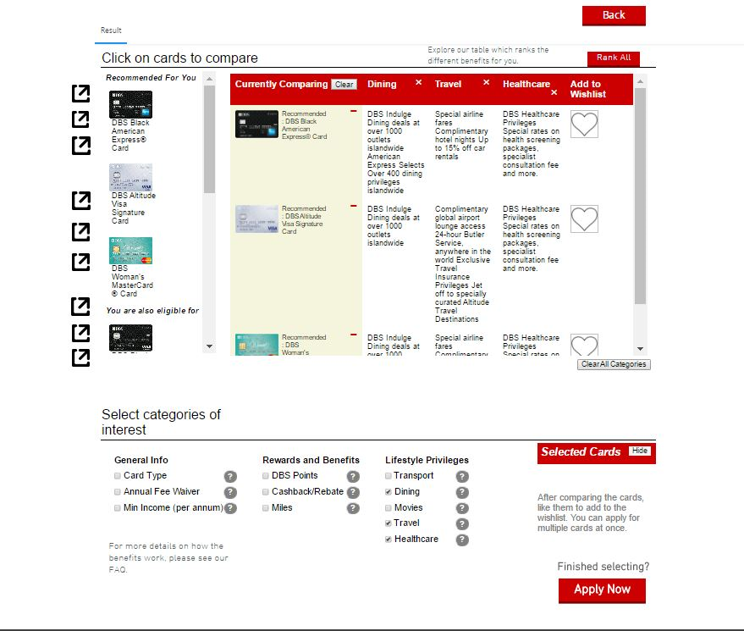**Figure 5.4.3.1** Wix + HTML Fully Functioning Card Comparison

#### Design Summary:

The cards panel and comparison table were placed on top, as a user feedbacked that it would be good to see the table first (since it was the main content).

#### Design Concepts Used:

**Priority of Information** and **Sequence of Action**: adjustments were made according to user preferences.

#### User Feedback: (Future Improvements)

Another user suggested removing the comparison categories panel altogether; and converting the comparison table columns into tabs (like Google Chrome). This way, all the categories will always be displayed in the table, but the user can directly choose to minimize (pin tab) or maximize the tab to show the details for that particular column.

## 5.5 Card Application

### 5.5.1 Stage 1: Initial mockup for Card Application

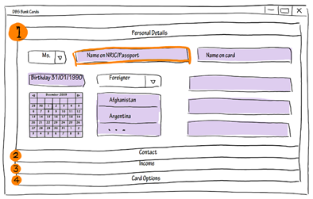

**Figure 5.5.1.1** Initial mockup- Card Application

#### 

#### Design Summary:

The initial mock up is a brief draft of application page drew by hand. The main skeleton of this page is to divide blanks into several small categories to minimize the information quantity in each section. It could prevent the situation that user is scared by the long application procedures and give up filling it.

#### Design Concepts Used:

The concept for this draft is increase **information visibility** and reduce **clicking time**. We divide the entire forms into various parts so that user would have more visibility about what is needed for the application. Since user are allowed to switch between different sections, they are free to complete the form in any order they want. The time to click between the first question and last question is decreased due to **Fitt’s law**. If it's in a list format, use might need to scroll down the entire page to check the first and last question.

#### User Feedback:

We found five testers and asked their first impression about this application page since the details were not completed. Most of them love the idea that we divide information into sections. But one tester provided a negative reflection because he thought the structure is not really innovative and he had seen many similar websites.

In another aspect, all of them think it would be more intuitive if the headers of each section are in a horizontal layout. It’s not convenient to read in a vertical order because the sequence will be broken by the expanded questions. Based on the test result, we decide to create a navigation bar for application page at the top of the screen.

### 5.5.2 Stage 2: Mock up of Application UI

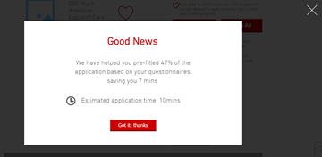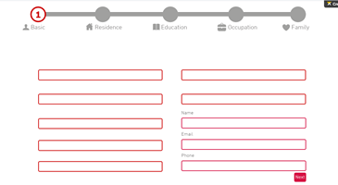

**Figure 5.5.2.1** Wix mockup- Card Application

#### Design Summary:

We created a mock up on Wix and unified the style with other pages to follow the standard style of current DBS bank website.

When a user clicks apply button, a pop-up window will show up to remind the user how many percentages of the application has always been filled and corresponding time has been saved. Followed by the main structure of draft and feedback from last user test, we designed a progress bar located at the top of the page. The highlighted number indicating the current page and user could click grey circles to manually move to next step.

#### Design Concepts Used:

The aim of the pop-up window is to reduce the potential pressure of user when they face plenty of tedious blanks required to fill in.

We also studied human’s visual habits. Based on the visual element of web UI study in the literature review (refer to literature research 4.3.1), the main path of users visual flow path will start from top left to the bottom right. Thus, we put a progress bar at the top left of the page so that the user will not miss it. The progress bar could **reduce click distance** and **enhance clarity** by indicating the current stage as well as displaying the process sequentially.

#### Heuristic Inspection:

We invited Professor and the Teaching Assistant to help us conduct the heuristic inspection together with the group members. We aimed to check whether the UI is intuitive and which part might cause ambiguity and error. Professor raised a situation that after clicking ‘OK’ from the previous pop-up window, a user might be confused about their pre-filled forms, as there is no marker or indicator to reflect the filling percentage. The series of grey colour might mislead the users and make them feel their pre-filled questions were missing.

Thus, we came up with the idea of designing a progress bar with different colours that look like a charging battery sign, and use it to represent the percentage of information a user has already filled in for each application section. However, the Professor thought it is still not appropriate since it could not accurately display the filling situation of various sections. It was still relatively difficult to visualize the progress in the current application page design. User might have to switch between different stages frequently to check the filling status.

### 5.5.3 Stage 3: Functional Application Prototype (first version)

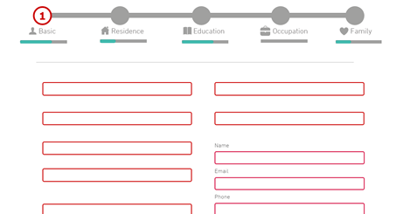

**Figure 5.5.3.1** Functional Wix prototype first version -- Card Application

#### 

#### Design Summary:

We created a functional prototype for the application page. With reference to the previous suggestions provided by the professor, we implemented two layers of progress bar to visualize the filling proportion and progress better. The top layer indicates the section the user is currently at, the second layer displays the filling percentage of the corresponding section. After the user completes one section, the progress will become full by colouring it in green.

#### User Feedback:

We conducted an informal user test and asked testers to complete the questionnaire and application process. They think the idea of the pop-up window is good. It reflects the outcome of user’s efforts in the questionnaire. However, the design is not emphasizing any main aspects of the application, and the majority of users may not pay attention to this page. The font size is also too small and the grey colour affects the reading experience. They felt uncomfortable in the eyes when they start to look carefully at the content of the pop-up window.

Furthermore, although the application form is partially filled in thanks to the questionnaire, users may still feel tedious about those blanks. They demand an improvement to enhance the experience of filling in many questions.

### 5.5.4 Stage 4: Functional Application Prototype (improved version)

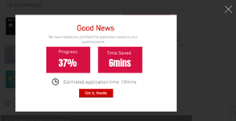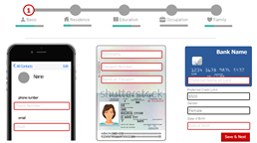

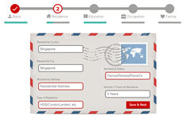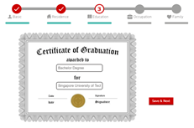

**Figure 5.5.4.1** Functional Wix prototype V1- Card Application

#### Design Summary:

We created gamified application forms for users to fill in, adopting a similar approach as the questionnaire section. Background picture displayed images that suggest the content to be filled in, which make users feel like creating a virtual passport (nationality information form), degree certification (education form), name card (employment form) or family photo (family form) during the application by completing the form.

#### Design Concepts Used:

Banks requires plenty of information due to security concern. Therefore, it is infeasible to decrease the number of questions in the application form. What we are already doing is to control the amount of information the user need to filled in the all sections of the application form. To further improve user satisfaction, we hope to make the process more engaging. Therefore, we brought in the **gamification** elements to reduce user frustration in completing the application procedure.

## 5.6 Card Details page

### 5.6.1 Stage 1: Identifying Problems and Comparing with Tabular Aspects

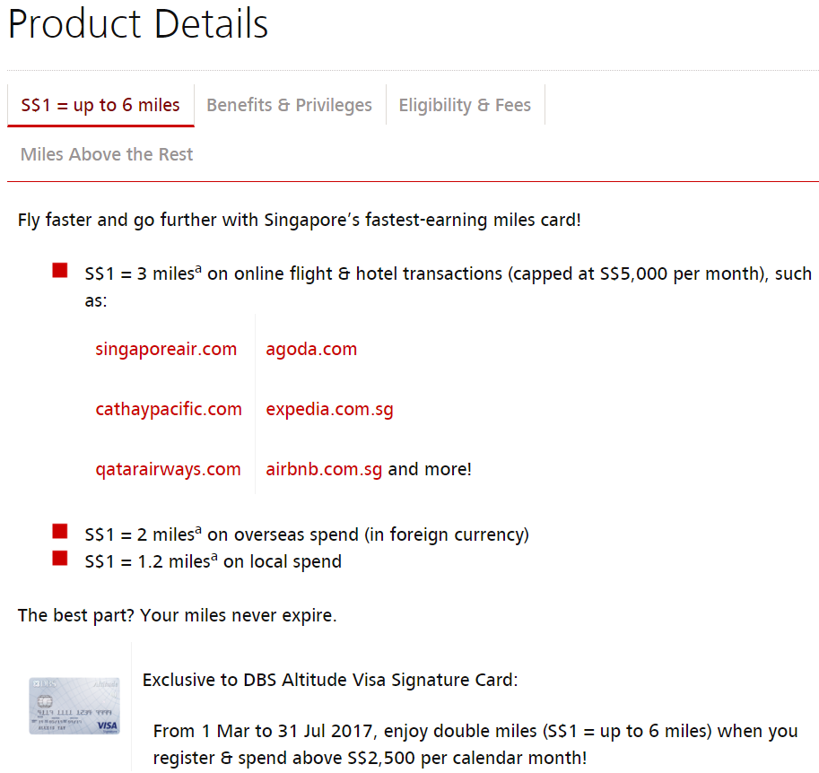

**Fig 5.6.1.1** Informations are disorganised and the access to various information has high click distance 7

#### Design Summary:

Before reinventing a new UI, we first identified the problematic features of the existing design. At this stage, we identified the disorganised information and the large click distance in accessing other important features of a credit card. It became clear to us that these issues can be improved by integrating the tabular aspect interface, as mentioned in literature review on exploratory search, to the card details page. Below is a mockup created during our group discussion. The page is divided into three columns: pre-credit card application, benefits and post-credit card application. Each cell contains details of of relevant service for that column.

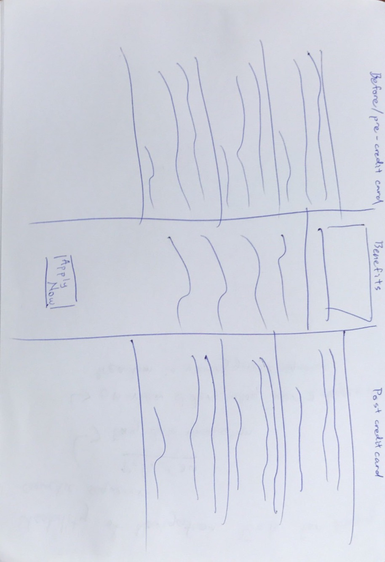

**Fig 5.6.1.2.** First mockup for card details

#### Design Concepts Used:

This draft is a variant of the tabular aspect interface and utilises **information visibility** and **mapping** for different features. The three columns in this page creates a mapping of the different information in a card detail page so users have an idea of how these information can be used in different scenario. At the same time, information are organised and consolidated under one page, increasing information visibility and reducing the number of artefacts.

#### User Feedback:

This design was done at an early stage, and our feedback was received from students in UI class. One useful feedback we received was that, instead of putting in all details into each section, the details page can be shortened by summarising the details and providing a link to the official page should the user want to find out more.

### 5.6.2 Stage 2: Card details prototype in Wix

#### 

**Fig 5.6.2.1** Wix prototype -- Card details

#### 

#### Design Summary:

We created the card details UI on Wix for the 9 different DBS credit cards. During implementation, we took the user's’ feedback into account and summarised the content of each service and provided a link to allow users to find out more. We also put in pictures that were descriptive of the content to increase the **learnability** of each service.

#### Design Concepts Used:

**Grouping** UI principle is used. We group similar information together in one column. In addition, **alignment** is emphasized here.

# 

# 6. Evaluation

Our evaluation process includes heuristic inspection conducted by all team members during prototyping stage as described in details in the previous section. They were duly recorded and referred to when designing new iterations of the prototype 5.

However, heuristic inspection alone is insufficient for comprehensive evaluation of our design. This is because we the team are the creator of the new system, and are thus considered as experts of the system. We are likely to have a biased view, and we may lack the domain knowledge of common users. In addition, user feedbacks were conducted informally. There might be other factors that affect their suggestions.   
   
Due to these reasons, it is necessary to perform a controlled and well-designed usability testing in our evaluation. In our study, we collected both user testing results (unintrusive, quantitative data) and user feedback (intrusive, qualitative data) as shown below5:

## 6.1 User Testing

### 6.1.1 Design

Due to the nature of our hypothesis (to test whether participants find the new system easier to use, and if it allows them to complete card application process faster compared to doing the same in the traditional system), the experiment is a within-subject experiment (the same group of subjects/users test out both systems. Each subject will complete the study individually, with the same instructions and same set of tasks.

**Independent variable**:

Type of bank card selection and application systems used: we have 2 systems: the traditional system and the new system.

**Dependent variable**:

1. Time taken for users to complete card selection and application process in each system, which may include time to answer questionnaire, view card details, and complete application form.
2. Number of card information viewed before making the decision.
3. Error rate, which includes unintended actions, wrong buttons to click, etc.

### 6.1.2 Participants

A total of 12 target users were recruited (mean age 22.0, range 19~25) from the Singapore University of Technology and Design (SUTD) for our experiment. These participants were chosen based on random sampling and convenience sampling so as to speed up the experiment process.

To minimize bias in experiment process, we divide the participants into two equal groups, A and B, doing the experiment in the following order:

**Table 6.1.2.1** Ordering of AB testing for User Groups

|  |  |  |
| --- | --- | --- |
| **Group** | **1st Website** | **2nd Website** |
| A | Traditional DBS Website | New Website |
| B | New Website | Traditional Website |

### 6.1.3 Materials

Two user profiles were carefully crafted to perform the usability testing (refer to Appendix B). Each user profile is written targeting one or two specific type of bank cards with all the information needed to complete the card application process. We want to make sure that the participants go through the normal process for selecting the bank cards, instead of randomly pick one in the experiment. Therefore we use user profiles instead of letting the participant choose bank cards for themselves.

A questionnaire is designed to gather user’s feedback for two websites (refer to Appendix D). There are two sections in the questionnaire. First section tries to gather user feedback regarding the new website, including any knowledge learnt, user satisfaction, concerns or doubts. The second section compares new website with traditional DBS website. Comparison criteria includes website complexity, information availability, consistency, learnability.

Laptop is the primary device used in this experiment, it has screen recording software for later data analysis. In addition, a moderator is assigned to participant to issue the tasks, answer their questions and collect their verbal feedback. All experiments were done in normal classroom settings in quiet environment. Figure 6.1.3.1 below is a sample experiment setting.

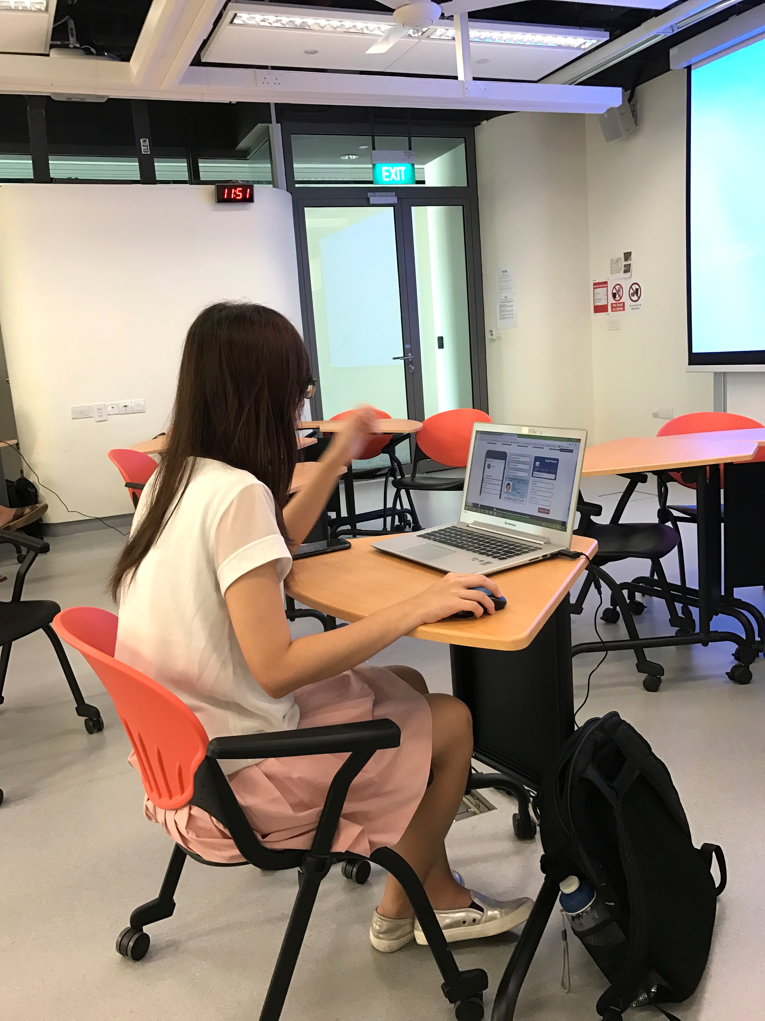

**Fig 6.1.3.1** User Testing

### 6.1.4 Procedure

Participants were recruited from voluntary sign ups. They were required to complete a total of two tasks in our experiment followed by a questionnaire. The participants were aware that the whole process was screen recorded.

In the first task, participants were presented with a user profile, and were told to select and apply a bank card for that person using the designated website (traditional DBS website or new website). After completing the first task, participants were given a chance to either take a break or continue. In the second task, they were presented with a different user profile and performed card application on the other website. Lastly, the moderator would invite the participant to complete the questionnaire and gather any other feedback.

The whole experiment procedure would take around 30min to complete per participant.

### 6.1.5 Result

In total, there are three modes of data collection from each of the subjects in the study:

* Time taken for completing card selection and application process;
* Total number of card details viewed before starting application;
* Number of unintended errors made by participants during card selection and application.

The result is collected in the following steps:

1. The team member who did not issue the user testing directly is assigned to analyse the screen recordings to minimize bias;
2. Time, card details views, and user error is recorded in a raw form (Appendix C);
3. Data is processed by calculating overall average, average within group, and sum, etc;
4. Processed data is plotted in appropriate chart or graph.

Below is the set of chart of graph of the user testing result data:

#### **Duration**

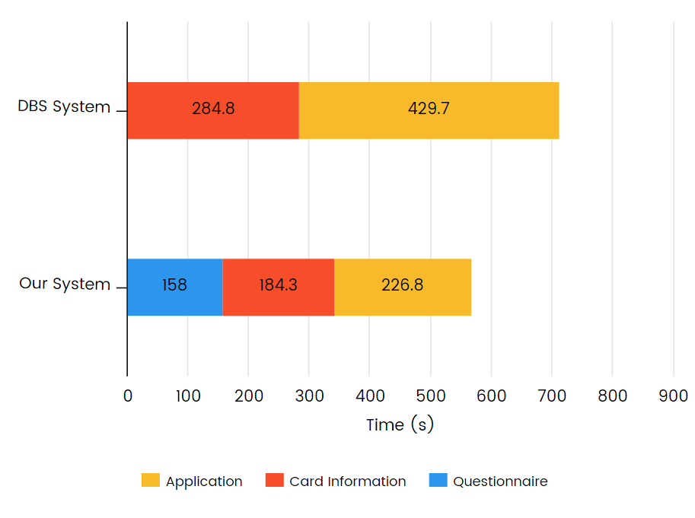

**Figure 6.1.5.1** Overall application procedure duration timing breakdown when using the traditional DBS system and when using our new system

To find out if the order of user testing (whether test the DBS system or our system first) matters, we plotted the stacked bar chart separately for users in each testing order:

|  |  |
| --- | --- |
|  |  |
| **Figure 6.1.5.2** Application procedure duration timing breakdown when using the traditional DBS system first | **Figure 6.1.5.3** Application procedure duration timing breakdown when using our new system first |

#### **Number of Card Details Viewed**

We compared the number of card details viewed when user is testing each system, as the more details page viewed, the less well-organized the page may be, in prioritizing and presenting information in card summary page.

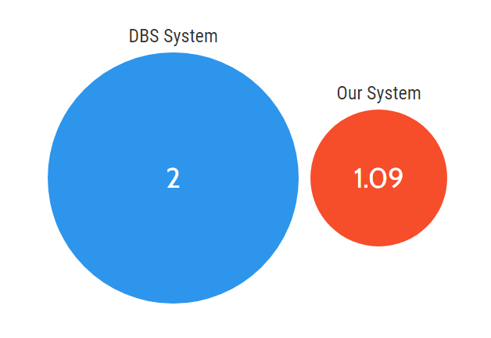

**Figure 6.1.5.4** Average card details page viewed when using the traditional DBS system and when using our new system

To find out if the order of user testing (whether test the DBS system or our system first) matters, we also plotted the graphs separately for users in each testing order:

|  |  |
| --- | --- |
|  |  |
| **Figure 6.1.5.5** Average card details page viewed when using the traditional DBS system first | **Figure 6.1.5.6**Average card details page viewed when using our new system first |

#### **User Errors**

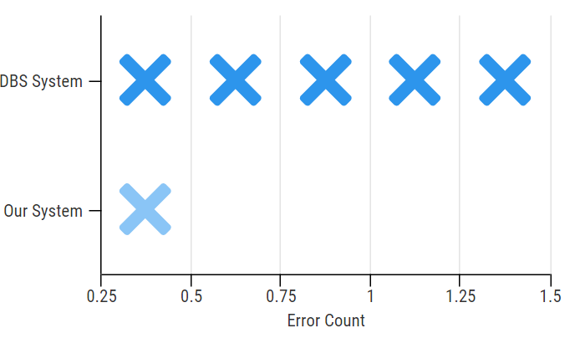

**Figure 6.1.5.7** Average unintended user error count when using the traditional DBS system and when using our new system

We also noted down the main errors encountered by users (they are all spotted in DBS system):

**Table 6.1.5.8** Specific unintended user errors encountered and their occurrence

|  |  |
| --- | --- |
| **Error (DBS System)** | **Occurrence** |
| Encounter error in card comparison, that only maximum 3 cards may be compared at one time | 5 |
| In card comparison page, after viewing card details, the cards select for comparison were gone | 4 |
| Website UI problem in card comparison page: when click "hide cards", the comparator will stop working unless page is refreshed | 1 |

Another observation which may not be strictly classified as user error, is that some participants need to search for the meaning of "SAFRA" and "credit card earn miles" when using the traditional DBS system. No such observation is seen when using our new system, as we have included in-page term explanations.

## 6.2 User Feedback

Apart from the quantitative data we collected from the above user testing, we also collected direct user feedback for qualitative analysis.

### 6.2.1 Design

The user feedback consists of two aspects, the verbal feedback collected by moderators during user testing, as well as user survey issued right after participants finish the user testing.

The post-experiment survey (Appendix D) is designed to be short (consists of only 15 questions, among which only 2 requires typing, the rest are all multiple choice or scaling questions) so as to speed up the experimental procedure, and attract participants who may not have much spare time.

Since this survey is mainly for qualitative analysis, we designed the questions to be more reflective of participant’s opinions and feelings towards the systems. Sample questions include:

* To what extent do you find the DBS System/Our System unnecessarily complex
* On the scale of 1 to 10, how easy is it to obtain information from the DBS System/Our system
* To what extent would you imagine new users learn the DBS System/Our System quickly

### 6.2.2 Participants

Part I (verbal feedback): user testing moderator and participants;

Part II (survey): user testing participants.

### 6.2.3 Materials & Procedure

Part I (verbal feedback): result is recorded by moderator privately, without disturbing user testing process;

Part II (survey): among paper-based survey and online survey, we chose the latter for its convenience, so that participants may be redirected to the survey link directly after completing user testing.

### 6.2.4 Result

The first set of result is collected from survey responses. The raw data is processed, such as by aggregating “agree” and “strongly agree” together for clearer visualization. The processed data is plotted as charts shown below:

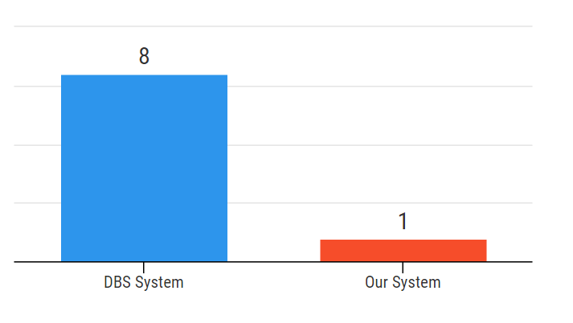

**Figure 6.2.4.1** Number of participants who find each system unnecessarily complex

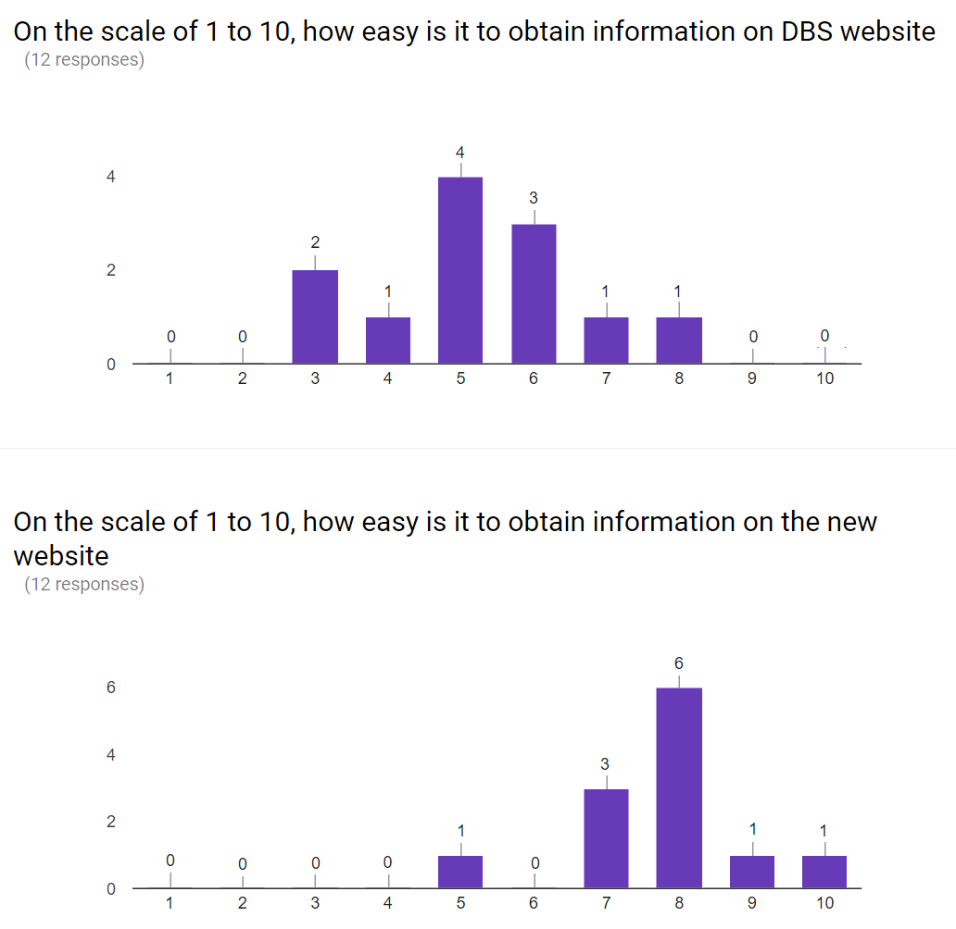

**Figure 6.2.4.2** Number of participants who ranked the ease of obtaining information in each system (ranking scale is 1 to 10, with 1 being the hardest to obtain information and 10 the easiest)

## 

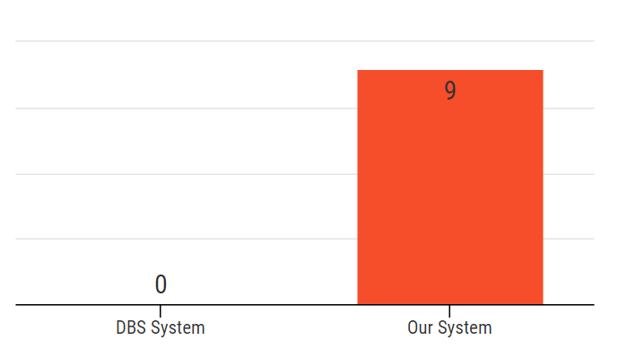

**Figure 6.2.4.3** Number of participants who feel satisfied with the credit card research and application process in each system

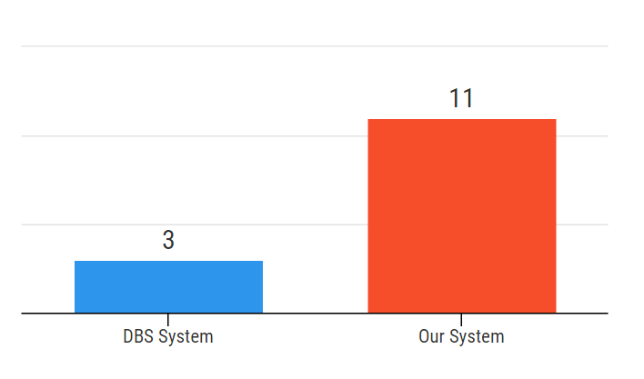

**Figure 6.2.4.4** Number of participants who would imagine that most people can learn the system very quickly for each system

In addition to survey response, we also collected verbal feedback from participants during the user testing process. The feedback for existing features and suggestions for new features are summarized below:

**Table 6.2.4.5** User feedback collected and our comment

|  |  |
| --- | --- |
| **User Feedback** | **Our Comment** |
| Some of the information looks like advertisment | Future work: follow-up survey on implication of the advertisement-like look |
| It was less messy(don't have to go back and forth all the time). But didn't feel that my time was necessarily made shorter. | Future work: improve time-saving strategies more efficiently |
| More colorful | Future work: follow up survey on what is the preferred color scheme, as for the current project we are inheriting the existing DBS bank website’s color scheme |
| For card comparison page display all the categories at the start, let users minimize/maximize instead of cancelling out totally (like google Pin tab /excel sheets) | Future work: implement and test out this feature |

**Table 6.2.4.6** New feature suggested by users and our comment

|  |  |
| --- | --- |
| **User New Feature Suggestions** | **Our Comment** |
| Contact specialist (real person) | Not essential for our problem scope, but certainly beneficial to include live chat feature |
| Statistic of the different cards | Future work: provide statistics in card recommendation and/or card details page to aid data visualization |
| T&C condition | Future work: integrate T&C in card details page without over-crowding the web page organization |
| Once key in the passport number, all related personal info should be filled in automatically, instead of doing that manually. U may work with the govt on that. | Not within project scope but possible suggestion to streamline the process |
| There should be headers or titles to show the current page or step | Future work: standardise page navigation headers for all pages |
| It could be better if there are pictures showing the details about privileges, like which airports could user enjoy the VIP room or which restaurant has discount for the card owner | Future work: balance between conciseness and details; show relevant images to explain card details better |

Furthermore, several users expressed their gratitude for the improved system we designed, some are presented below:

* “Process of application is smooth and intuitive. With the recommendations, it is also easier to find cards that are suited for me, and I would not have to look through the details or compare cards which I may not have any information about at the start. Time saved :)”
* “It’s very user-friendly to filter out information user doesn’t need based on the pre-filled questionnaire”
* “The recommendation system is awesome for people who don't know much about bank cards”
* “Card comparison is user-centred and flexible”
* “No pop-up ads for cards compared with DBS website”
* “Fun application process; I like the progress bar”

## 6.3 Result Interpretation

### 6.3.1 Time Efficiency

From Figure 6.1.5.1, we noted that even though we added in questionnaire in our new system, and it takes some time to complete the questionnaire, the card comparison as well as application time is reduced when using the new system. Our system thus proved to be more efficient in reducing the time needed to accomplish the same goal of card research, selection, and application.

It is also important to note that during user testing, participants were answering questionnaire based on given scenario. In real life, most of the applicant will answer the questionnaire for themselves, which should reduce the questionnaire time as well.

### 6.3.2 Information Organization

Figure 6.1.5.4 suggests that participants have fewer views on card details which implies that our information organization is more efficient to supply users sufficient content to make an informed decision, without having to refer to card details page.

The survey response (Figure 6.2.4.2) shows that the median rating for DBS system is 5, and our system is higher with a median rating of 8. It also confirms that participants find it easier to obtain information in our system.

### 6.3.3 Clarity and Mastery

The survey response presented in Figure 6.2.4.1 shows that fewer participants find our system unnecessarily complex, suggesting that our system is easier to understand and navigate, and reduces user's mental workload.

Another survey response (Figure 6.2.4.4) suggests that more participants find our system will be easy to learn for other users. This shows that participants were convinced by the clarity of our design, that they can confidently predict the same feeling of mastery for future users.

### 6.3.4 User Satisfaction

From user testing and results, several evidences have supported our claim of our system giving users greater satisfaction:

Firstly, the user testing result in Figure 6.1.5.7 shows that there are fewer unintended errors in our system, implying that users are less likely to be disturbed by error messages when using our system, thus making the process more enjoyable.

Also, the survey question on how satisfied are the participants when using both system (Figure 6.2.4.3) suggests that more participants find out system more satisfying to use.

Most importantly, the majority of the verbal feedback we collected express positive emotions, with vocabulary such as “fun process”, “user-friendly”, “smooth”, and “intuitive”, explicitly demonstrates the user satisfaction our system creates.

### 6.3.5 Special Observations

We divided our participants into two groups to minimise the bias that may be present due to the testing order. While analysing the results, we indeed find that there is a difference when a user started with one system over the other.

Although this discrepancy may not be statistically significant given our small sample size, it is worth noticing that user’s general mastery of credit card research and application improves with experience. It also confirms our experiment design that it is more accurate to divide participants into different control groups.

# 

# 

# 7. Impact

Based on the evaluation of our user study results, shown below is a table summarizing all the positive impact that our system brings to users. We have ranked the impact in terms of importance/impact level as shown:

**Table 7.1** Ranking and Summary of Positive Impacts on Users by our system

|  |  |
| --- | --- |
| **1** | **Accelerated and simplified process of searching, comparison/ selection and application**  Users can find specific products they have in mind and complete required action items quickly. This is done by the **filtering of unnecessary/irrelevant details** for them by narrowing down the options for them based on the questionnaire, as well as by reusing information gathered from other section of a workflow to assist the completion of a mandatory action item (e.g. filling application forms, submitting supporting documents, etc.) |
| **2** | **Interface with high learnability and ease of navigation**  Any user can pick up the system easily and get used to it within a relatively short period of time. Information is organized properly, with the use of clear categorization and navigation systems, and user guides are integrated into respective sections. |
| **3** | **Assistance in making more informed choices**  We provide recommendations along with comparison features that are easy to use. Additionally, we do not impose limits on the number of items that can be compared at any one time.  In doing so, we empower users to choose the most suitable product or services for themselves, especially for computer literates without sufficient domain knowledge in a certain field.Our system also helps users to search for specific products easily. |
| **4** | **Decreased boredom /sluggish feelings for form-filling and applications**  This is achieved through the use of **gamification** and using questionnaire to re-fill application information. |
| **5** | **Easy reversal of actions + Relatively low error rates**  Convenient toggling between overview and details for each section. |

# 8. Conclusion

## 8.1 Future Work

### 8.1.2 Improvements:

Based on the evaluation results and user feedbacks and comments, there are still several aspects we could improve:

1. Further enhance the aesthetics. Our focus for this project is a scientific approach to control the information overloading and reduce user frustration. Since we are targeting DBS website, we followed the original DBS shape and colour scheme for standardisation. Yet, we are aware that a beautiful website could leave a strong first impression to the users, so it’s a good direction for us to improve our prototype.

For example, the current card comparison page is slightly bloated and the position of the category list is hard to notice. We could also standardise the navigation headers for all pages, and some testers reflected that they would like to see more pictures appeared on the website. An impressive art design will make our website easily remembered by more users. It may generate a chain reaction and bring a higher volume to our website.

2. It is better to recommend cards in multiple ways and improve the recommendation algorithm. We could design more practical options for users during the card recommendation stage. If a user would be willing to tell us their job titles or companies in the questionnaire, we could recommend the most popular cards among people who has the same title or work in the same company applied before. We could also divide popular cards into groups. If user skips questions in the previous stage, it’s still possible to generate a legit recommendation result.

3. New features: For instance, we could add in term and conditions and include most frequently asked questions in the next version of our website. Furthermore, there is supposed to be a channel to contact the customer service centre. We also received feedbacks about adding the data visualisation on the recommendation page. We should polish those defects to further improve our product. Also, the current card application page does not have the strict input checking as DBS website. It is acceptable in our prototype. However, in the future, we need to add this function to ensure the data accuracy and prevent potential attacks.

### 8.1.3 Other ideas:

We could seek collaboration with the government to collect people’s information in a secure way. User could just key in their name and FIN number or passport number to check the recommendation result and finish the application in a few seconds based on the database information. It could significantly increase the utilizable ratio of government data and reduce the user’s frustration on repetition.

## 8.2 Application to other domain areas

Our integrated UI/UX system can be modified to suit a wide range of products and services, including but not limited to:

### Web Services:

1. **Visa Applications, Government Services:** Simplify complicated process and help users to optimize their time by choosing the most suitable type of Visa, as processing of documents could take up to months.
2. **Travel Planner**: Recommend travel package to user based on the questionnaire that the user filled up. Organise package information in an exploratory manner.
3. **Travel Insurance Selection and Claim:** Recommend suitable travel insurance plan for the user and simplify the claiming process using a guided website UI design.
4. **Music Album, Reading List, Movie List:** Age limit-rated movies filtered out for underaged viewers to reduce total search time.

### E-commerce apps

1. **Restaurant Booking Applications:** most suitable places to eat, given the constraints of budget, cuisine type preferred, allergies, etc.

#### **Supermarket Applications:** recommend brands of product to buy given the budget constraints and quality requirements (e.g. toilet paper rolls)

### Daily Products:

1. **Entertainment- TV**: automatically display TV channel based on user preferences and schedule
2. **Personalized services:**
   1. **Diet plans:**  recommend food to suit diet plans based on income level, age, gender etc
   2. **Suitable Dress Code:** for a certain event, based on culture or occasions

### Education / Psychology:

1. **Employing the use of gamification**: encourage primary school students to **complete exercises or homework**, as these are typically seen as something they are forced to do and regard as a chore. The psychological motivation would make studying a lot more fun and enjoyable for them.
2. **Online examination system-** **progress bars** for each section to inform users about how much they have completed, and also as a form of motivation

### 

The following are some examples of UI mockup for other domain applications:

### 8.2.1 Visa Application:

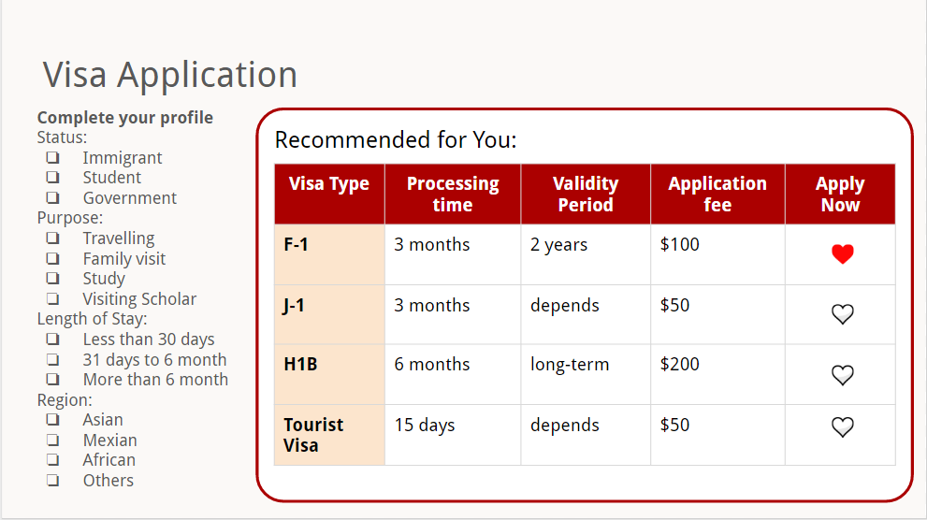

**Figure 8.2.1** Visa Application

**How this works:**

The user is asked to complete their profile on a questionnaire in the form of a checklist, of which options can be changed anytime. The comparison table shows recommendations that will be updated according to user input. After a quick analysis of the comparison properties, the user can easily arrive at a decision and apply directly by clicking on the heart-shaped button which brings them to the application page.

**Inspiration:**

Government services contain massive amounts of information which are complex and unfamiliar to most first-time users. Also, some users might not know what is the best type of visa to apply for, due to lack of information and difficulty in processing all the information. Hence, applying our UI system will make the whole process easier, especially for first-time users who are travelling overseas. They will feel more relieved as they are empowered to compare all suitable choices and perform cost-benefit analysis conveniently using our system.

### 8.2.2 TV Example:

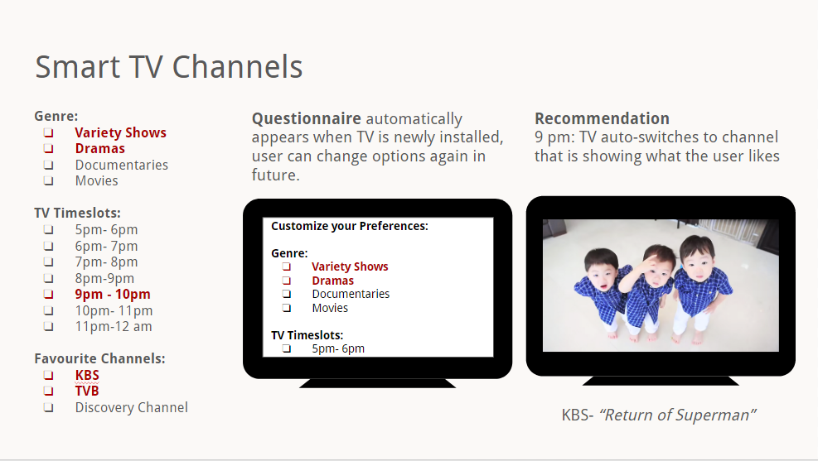

**Figure 8.2.2** Smart TV Channels

**How this works:**

When the user switches on the television at 9pm, any channel displaying the genre they like would be considered- and of course, their favourite channels would come first. An algorithm is used to maximize the preferences of the users, constrained by the range of their free timings. For example, this channel contains a show that belongs to one of the user’s favourite genre, and it is also the user’s favourite channel. Hence, it is automatically displayed first. If there are multiple choices that satisfy at least 1 criteria in the given timeslot, the user would be given a list of choices to select from.

**Inspiration:**

Our inspiration came from *Starhub Cable TV*, which offers a recording function of shows. However, users might have difficulty in deciding which shows to record as there are many channels, and shows that are broadcasted in the same time slot cannot be recorded simultaneously.

Hence, we could recommend the users a list of shows to record based on their preferences(favourite channels) and priority ranking(which shows are the most important); and a algorithm implemented to suggest the best combination of shows. We can also recommend similar/related shows/channels.

From this inspiration, we thought of taking a step further to enhance functionalities. The television automatically switch to a channel when the user turns it on at a certain time based on the user preferences. By doing so, the user would not have to spend time unnecessarily flipping through multiple channels to determine what channel they should watch.

### 8.2.3 Restaurant Booking App:

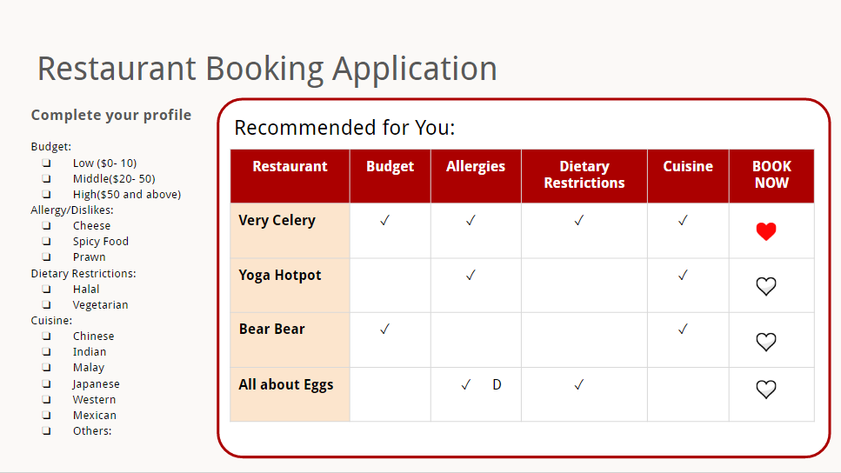

**Figure 8.2.3** Restaurant Booking Application

**How this works:**

The user will indicate their budget, type our system filters out food items containing certain ingredients that some users might not like / is allergic to (such as cheese, milk, prawns).

#### **Inspiration:**

This system can be incorporated into existing food apps such as Eatigo. Currently, existing food apps recommend places with discounts/promotions that are classified into broad categories such as “Japanese, Buffet, Ala-carte, Western” etc. However, such systems are not very personalized. Therefore, incorporating our UI helps narrow down the choices for users so as to cater to their taste buds, we allow them to compare candidate choices conveniently.

## 

## 

## 8.3 Concluding statement

In this project, we aimed to increase information organisation, user satisfaction and learnability of DBS bank card website, and through which to address the information overloading problem faced by users of major services and applications. We applied streamlining and gamification method as the main approaches, incorporating UI design guidelines and principles such as grouping, mapping, consistency, reduced click distance, etc.

Looking back at our design approach, we feel that the whole iteration process has been done thoroughly to obtain essential feedback. Modifying the original linear application flow of DBS website, we added a questionnaire step to gather basic user information, and use this at each following step to recommend bank cards and pre-fill applications. We conducted a heuristic inspection and user feedback with each prototype.

Based on the evaluation result of usability testing, our website indeed saves time for the user to apply to bank cards, and their satisfaction and learnability is improved. Nevertheless, we still have other areas of improvement based on user feedback, further exploration is needed.

All in all, we find that our product has the potential to be adopted in many services as ways to simplify their interface, especially those containing a wide range of product selection and massive amounts of information to be processed by the user.

Reflecting back as a team of UI designers, we have learned a lot during this project. It inspired us to put the UI knowledge into practice. Every time we referred back to UI guidelines, we obtained new insights and gained a deeper understanding of it. During the prototype development stage, our group dynamics helped us generate creative solutions, as we gave constructive feedback to each other. After the project, we became more appreciative of the effort that user experience designers have put into designing websites and apps. As future engineers, this project inspires us to constantly thinking about users in whatever software we design in the future by using the UI guidelines and principles in practice.

# 

# 

# References

[1] Create a Personalized Avatar. (2015). *Edmodo*. Retrieved from

<https://support.edmodo.com/hc/en-us/articles/205009184-Create-a-Personalized-Avatar>

[2] Liu Heshan, Ma Fujun. (2010). Research on Visual Elements of Web UI Design. *IEEE 11th International Conference on Computer-Aided Industrial Design & Conceptual Design (CAIDCD), 2010.* DOI: 10.1109/CAIDCD.2010.5681317

[3] L Shin. (2014) 10 Steps to Conquering Information Overload. *Forbes.* Retrieved from

<https://www.forbes.com/sites/laurashin/2014/11/14/10-steps-to-conquering-information-overload/#31e3eae97b08>

[4] Nichols, Mahmud, O’Donovan (2016). Proceedings of the 21st International Conference on Intelligent User Interfaces. *IUI'16 21st International Conference on Intelligent User Interfaces.* Retrieved from <http://dl.acm.org/citation.cfm?id=2856767>

[5] Planning a Usability Test. *Usability.gov*. Retrieved from <https://www.usability.gov/how-to-and-tools/methods/planning-usability-testing.html>

[6] Rutherford, Abell, Churcher, McKinnon (2010). Usability of Navigation Tool for Browsing Genetic Sequences. *AUIC '10 Proceedings of the Eleventh Australasian Conference on User Interface , Volume 106 Pages 33-41*. Retrieved from <http://dl.acm.org/citation.cfm?id=1862287>

[7] Screenshots were taken from <https://www.dbs.com.sg/personal/cards/credit-cards/dbs-altitude-cards?pid=sg-dbs-pweb-cardshome-featuredprod-cards-altcard-btnlearnmore->

[8] Streamline definition (n.d.). *BusinessDictionary.* Retrieved from <http://www.businessdictionary.com/definition/streamline.html>

[9] W Poon. (2012) What is streamlined interface? *StackExchange*. Retrieved from <https://gamedev.stackexchange.com/questions/34521/what-is-streamlined-user-interface>

[10] What is Gamification? (n.d.). BunchBall. Retrieved from <http://www.bunchball.com/gamification>

[11] Wu, M., Turpin, A. et al. (2010). Presenting Query Aspects to Support Exploratory Search. *11th Australasian User Interface Conference (AUIC2010), Volume 106*. Retrieved from <http://crpit.com/confpapers/CRPITV106Wu.pdf>

# Appendix

## Appendix A- Card Comparison Page: Design Exploration Details

#### Iteration 1

**Testing Type :** Heuristic Inspection **Item Type :** Initial prototype (PPT)

**Design Summary : *Clear grouping-*** Comparison Categories are aligned vertically as a checklist on the left. Comparison table takes up most of the space. Only Recommended Cards are provided for comparison. **Session Objective/ Summary :** Validation of concept, test if user understands how it works, whether this comparison tool is potentially useful and beneficial, and how it should work. **Detailed Feedbacks:** Comparison Table is good. Decide whether to expand information box (by clicking) or use mouseover dialog box. Other cards are missing, users should be allowed to choose from the other range of cards beside the recommended ones only.

**Improvements to make:** Refine layout further, add in other cards to choose from, such as what the user is eligible for and what similar users have bought.

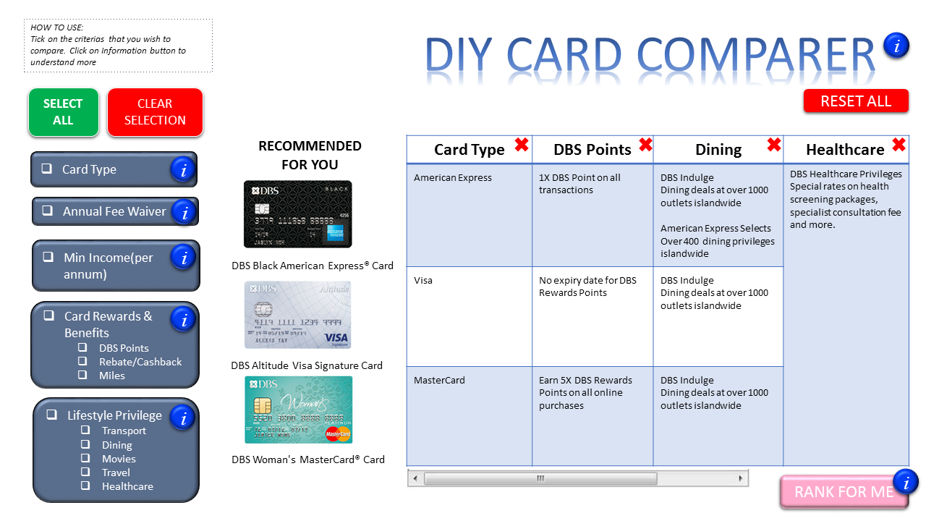

#### Iteration 2

**Testing Type :** Heuristic Inspection **Item Type :** Refined, more detailed prototype (PPT)

**Design Summary:** Comparison Categories placed on the left(unchanged). 3 columns of credit cards on top, with wishlist on the right side. Table spans the bottom section with button features on the right.

Users can add multiple cards(splitted into 3 distinct categories) and select from various comparison categories to compare together in the comparison table.  **Session Objective/ Summary:** Comparison Categories placed on the left(unchanged)

3 columns of credit cards on top, with wishlist on the right side

Table spans the bottom section with button features on the right. **Detailed Feedbacks ⇒ UI guideline violations discovered:**

* Too many unnecessary buttons, remove them. Unnecessary features such as “Reset to default”. ⇒ Low info to admin ratio, too many unnecessary buttons /labels
* Group similar content together to simplify layout and make it less crowded ⇒ Too much space wastage / Over cluttered
* Cannot observe directly/easily whether the cards/comparison category have been added ⇒ Mapping & Grouping principle is not applied.

**Improvements to make:**

* Allow users to add/remove cards by clicking on them directly(provide visual feedback by highlighting when user mouseover)
* Combine 3 sections of credit cards boxes into 1 column
* The cards are placed as a column on the left for selection and the comparison categories as a section of checkboxes on top, such that their position corresponds to the comparison table layout.
* We apply “mapping principles” so that the user can map the table content to their current selections from each section; this is done by grouping the selection panels together with the corresponding parts(axis) in the table.



#### Iteration 3

**Testing Type :**  Usability Testing **Item Type :** Wix Prototype(1) **Design Summary:** Rough layout shown , major buttons implemented. **Session Objective/ Summary:** User evaluated main features and their placements/arrangements **Detailed Feedbacks ⇒ UI guideline violations discovered:**

“Provide option to hide/show wishlist if possible like phone app. Don’t keep it displayed all the time.” ⇒ Low flexibility/ no manipulation allowed **Improvements to make:** Provide button for user to toggle (show/hide) the wishlist- which is hidden by default.

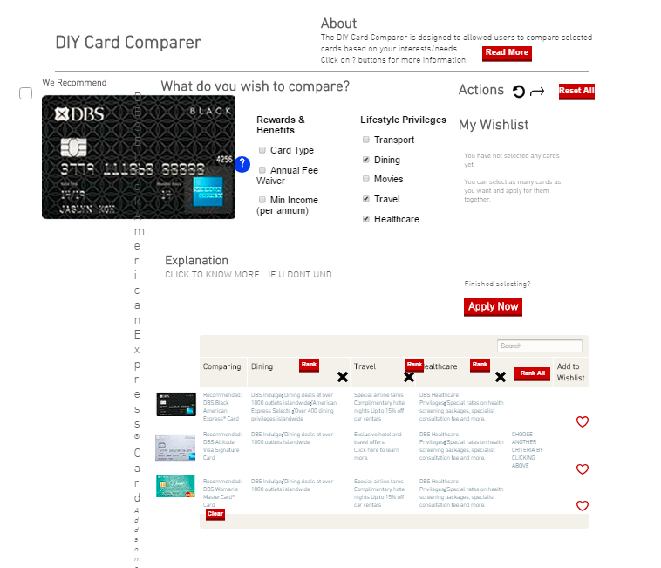

#### 

#### 

#### Iteration 4

**Testing Type :** Usability Testing **Item Type :** Wix Prototype(2) **Design Summary:** 3-column layout: Select Cards column takes up the whole of left side; Comparison categories and table takes up the middle space. **Session Objective/ Summary:** Evaluation of first impression- very cluttered and confusing **Detailed Feedbacks ⇒ UI guideline violations discovered:**

“I don’t know where to start. Should I choose cards first or select categories?”

⇒Constraints not in place for layout to direct user action

Sequence of action not clear

“Layout looks so messy and cluttered. Seems like too much information…”

⇒ (Over-cluttered, poor aesthetics and organization) **Improvements to make:**

Remove “Compare” buttons below card as they are too bulky.

Let the comparison categories span the whole top part, with “Wishlist” on the right.

Place the <Select Cards> column and the comparison table in the bottom part.

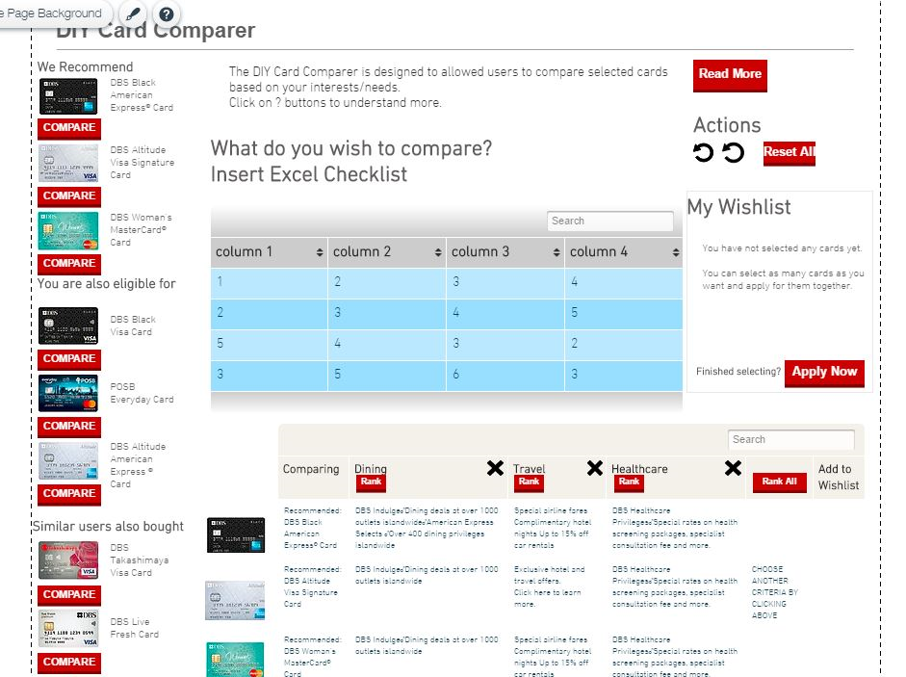

#### Iteration 5

**Testing Type :** Usability Testing **Item Type :** Wix Prototype(3) **Design Summary:** Comparison categories implemented as checkboxes under 3 main categories. “Rank” button implemented for each category in comparison table. **Session Objective/ Summary:** Feedback for Navigation Gestures

**Detailed Feedbacks ⇒ UI guideline violations discovered:**

“Hide wishlist (similar to what previous user said), provide bigger space(full-width) to choose comparison categories. Don’t like horizontal scrolling to see the table, I rather scroll vertically for everything on the page.” ⇒ Low ease of use in terms of navigation **Improvements to make:** Comparison table space will be maximized as far as possible so that user do not have to scroll so much; however horizontal scrolling will still be present due to page width limitations and the nature of the table(wide width).

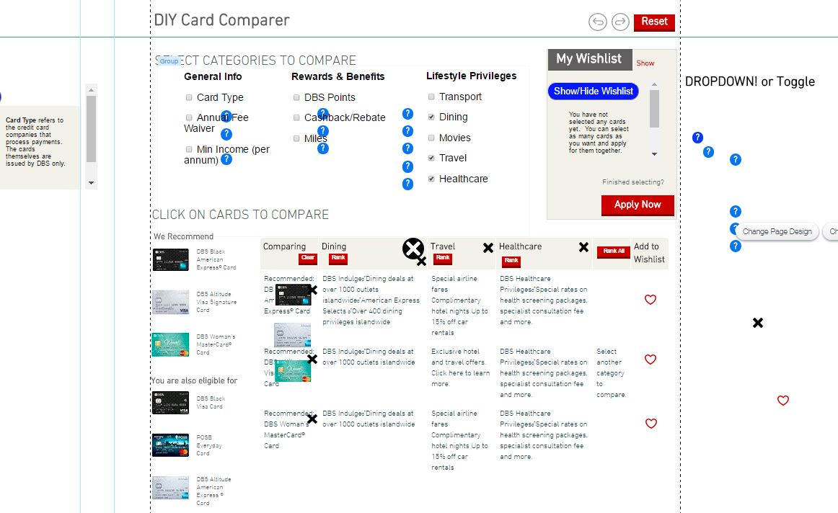

#### 

#### 

#### Iteration 6

**Testing Type :** Usability Testing **Item Type :** Wix Prototype(4) **Design Summary:** Headings are more prominent using white-on-black contrast. Mini “info-desk” to display explanation of terms when user mouseover. **Session Objective/ Summary:** Overall Look and Feel (this user is very particular about how nice a page looks) **Detailed Feedbacks ⇒ UI guideline violations discovered:**

“Black-background headings looks so ‘Chunky’. “ ⇒ Visual distraction

“I can’t look at two places at one time, just show the information directly on the same spot when I mouseover the question mark.” ⇒ Low visibility / redundant admin

**Improvements to make:**

* Remove distraction by replacing white on black section headers with capitalized letters and a simple line divider, so that the heading still help in segregating content without being distracting.
* Display information directly on mouseover, remove redundant “Information Desk” section.

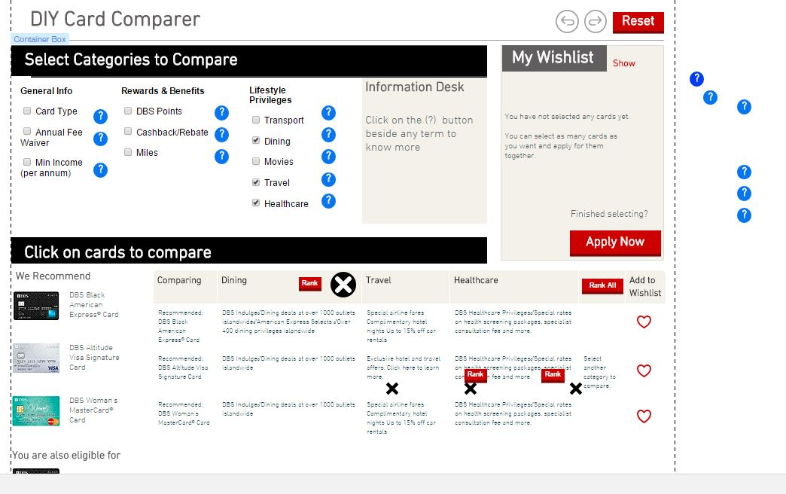

#### 

#### 

#### Iteration 7

**Testing Type :** Heuristic Inspection  **Item Type :** Final Working Prototype- HTML (embedded as website on Wix) **Design Summary:**

* Everything is formatted and coded with HTML/CSS/Javascript.
* Instead of a “Rank” button for each category, a **“Rank All”** button is provided- which links to a separate excel sheet that ranks every category in 1 big table for all the cards.
* Interface looks less cluttered as many functions is embedded in Javascript:
  + Unnecessary buttons are removed as users can simple click/unclick on the card to add/remove them from table.
  + Cards are highlighted when user hovers their mouse over them

**Session Objective/ Summary:** Inspection of whole page before user testing: Colour scheme, interactions and navigation **Detailed Feedbacks ⇒ UI guideline violations discovered:**

* Blue question mark buttons are distracting ⇒Undesirable visual distraction
* There is no obvious feedback that cards were selected and added to wishlist, because wishlist was hidden by default. ⇒ Low Visibility of System Status as wishlist is hidden by default and user does not know the card(s) have been added

**Improvements to make**:

* Change question mark to gray-colour to attract less visual attention
* **Show wishlist by default** so that user can see direct feedback upon liking a card in the comparison table.

(Default screenshot when user first enters page)

## 

(When User mouseovers the “?” button)

## 

## 

## 

## 

## Appendix B- User Testing Scenario

#### **Scenario 1**

You are helping your aunt to apply for a DBS bank card.

Your aunt, Barbara Lim, is married with two lovely daughters. She is the Vice President at a XYZ bank after joining the company in 2011, now managing a team of six. Despite her busy schedule, she really values work-life balance and tries to save time for herself. She is a huge fan of Yoga and enjoys running, two weeks ago, she just finished a 5k kids-parent family marathon. In addition, she enjoys online shopping to save her precious free time. Every morning, she takes cab everyday to drop and pick up her children to school on her way to work.

In terms of bank cards, she doesn’t have a specific type in mind. Her annual income is about S$120,000. Nevertheless, she wants a good deal and a card that suits her.

More information about Barbara:

* Mobile: 92228888
* IC: S2222888G
* Email: [Barbara_lim8@gmail.com](mailto:Barbara_lim8@gmail.com)
* Nationality: Singapore Citizen
* Date of birth: 15/01/1980
* Education: Bachelor’s degree at Singapore University of Technology and Design
* Address: 01-01, Barbara Road, Singapore 222888 (fully-owned landed properly; she’s lived their for 6 years)

Please help her to apply for a bank card at <https://watanabeshirokuma.wixsite.com/uiproject>

#### **Scenario 2**

Your elder sister Cindy Tan is a recent graduate from Singapore University of Technology and Design. She is now the marketing head in a local IT startup. She loves her work because it offers plenty of opportunity for traveling, that it is almost like a routine for her. Her monthly income is only about $3400, but her company is providing her a small apartment at 01-02, Barbara Road (Singapore 222888) since last year.

Cindy is currently single and available. She may be starting a family after she gains some experience in the workplace. In her free time, she loves to read and go to online shopping for designer clothes.

In terms of bank cards, she wants to get the most benefits. She wants to use it when she travels overseas too.

More information about Cindy :

* Mobile: 92228889
* IC: S2222889G
* Email: Cindy_tan8@gmail.com
* Nationality: Singapore Citizen
* Date of birth: 15/01/1990
* Company: Star Agency (an IT start-up)
* Education: Bachelor’s degree at Singapore University of Technology and Design
* Address: 01-02, Barbara Road, Singapore 222888 (fully-owned landed properly; she’s lived their for 6 years)

Please help her to apply for a bank card at <http://www.dbs.com.sg/personal/cards/default.page>

### 

### 

## Appendix C- Screen Recording Analysis Raw Data

|  |  |  |  |  |  |  |  |  |  |  |  |  |  |
| --- | --- | --- | --- | --- | --- | --- | --- | --- | --- | --- | --- | --- | --- |
|  | | Wix First, Group A Scenario A (Val) | | | DBS First, Group A Scenario B (Yujia) | | | Wix First, Group B Scenario A (XY) | | | DBS First, Group B Scenario B (JH) | | |
| 1 | 2 | 3 | 4 | 5 | 6 | 7 | 8 | 9 | 10 | 11 | 12* |
| Wix | Questionnaire duration (s) | 270 | 270 | 240 | 130 | 72 | 120 | 110 | 180 | 90 | 140 | 116 | NA |
| Checking card information duration (s) | 200 | 360 | 480 | 239 | 55 | 73 | 150 | 180 | 180 | 80 | 30 | NA |
| Application duration (s) | 316 | 300 | 420 | 249 | 190 | 120 | 180 | 220 | 180 | 190 | 130 | NA |
| Number of card details viewed before application | 0 | 0 | 1 | 3 | 1 | 1 | 3 | 1 | 2 | 0 | 0 | NA |
| DBS | Navigation duration (s) | 60 | 80 | 50 | 60 | 70 | 20 | 23 | 10 | 10 | 40 | 60 | NA |
| Checking card information duration (s) | 20 | 270 | 150 | 990 | 320 | 70 | 140 | 220 | 180 | 230 | 60 | NA |
| Checking card information duration (s) | 80 | 350 | 200 | 1050 | 390 | 90 | 163 | 230 | 190 | 270 | 120 | NA |
| Application duration (s) | 450 | 360 | 540 | 550 | 318 | 460 | 210 (incomplete) | 250 (incomplete) | 220 (incomplete) | 330 | 124 (incomplete) | NA |
| Number of card details viewed before application | 0 | 1 | 1 | 5 | 3 | 1 | 1 | 4 | 3 | 2 | 1 | NA |

* We don’t have the data of participant 12 due to technical glitch. But we did recorded down his verbal feedback during usability testing.

## Appendix D- Questionnaire (Post-testing)

We used Google Form for questionnaire.

(Weblink: <https://goo.gl/forms/qYiA5mdBQXh94qDq1>)

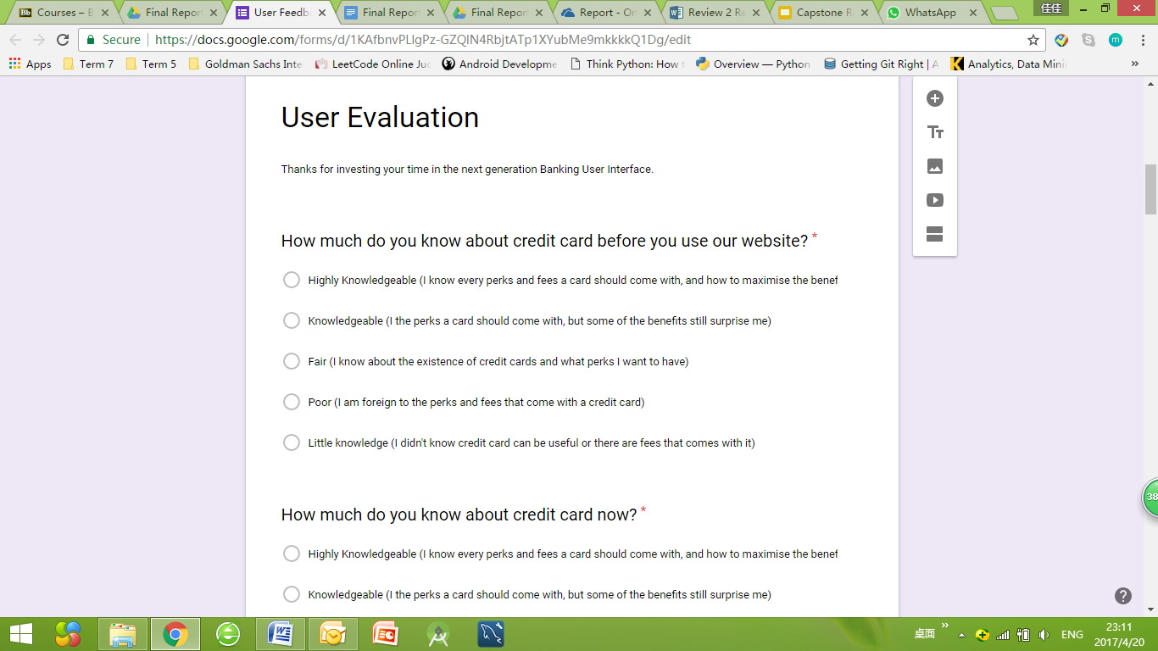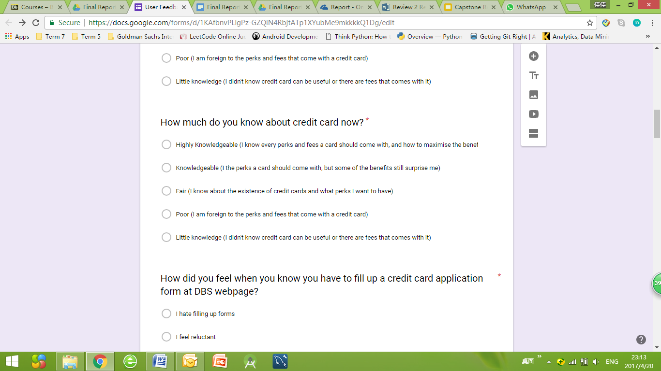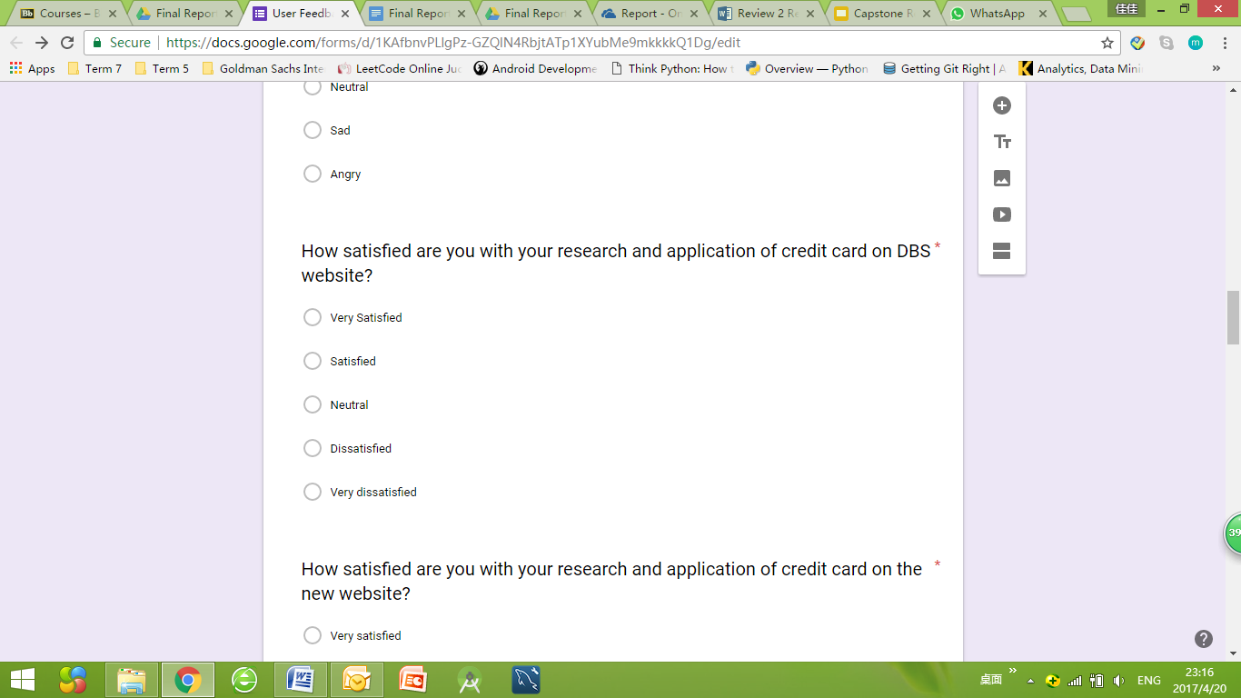

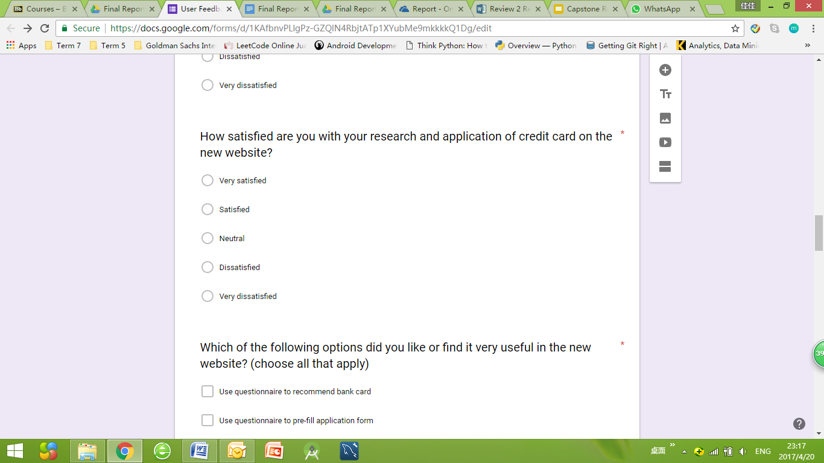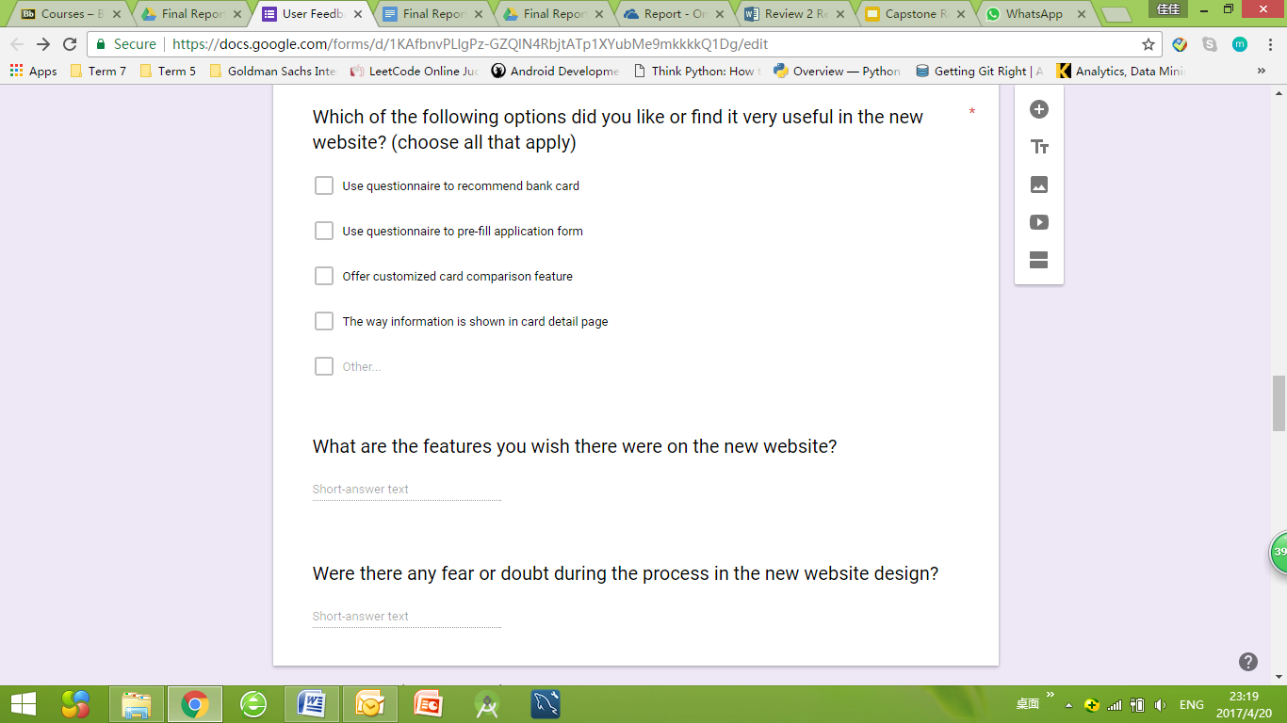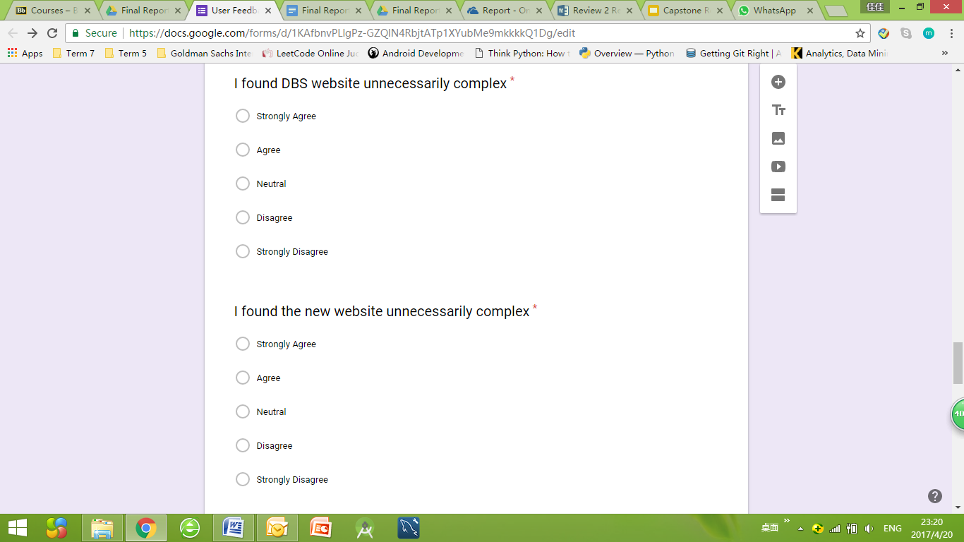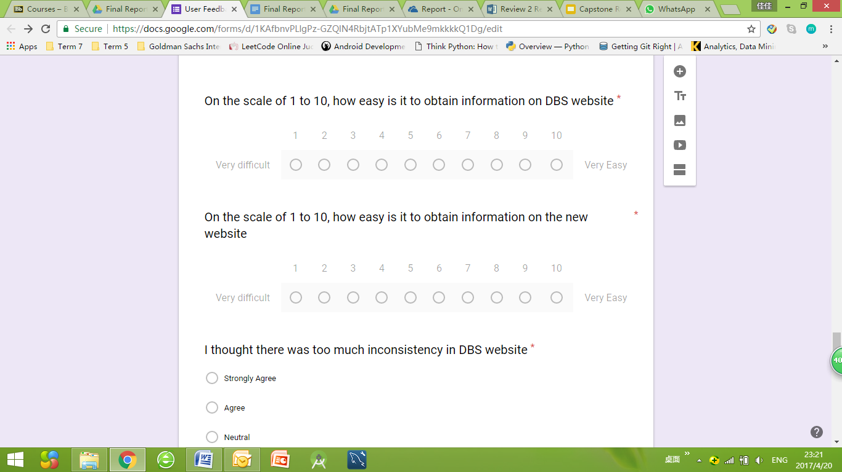

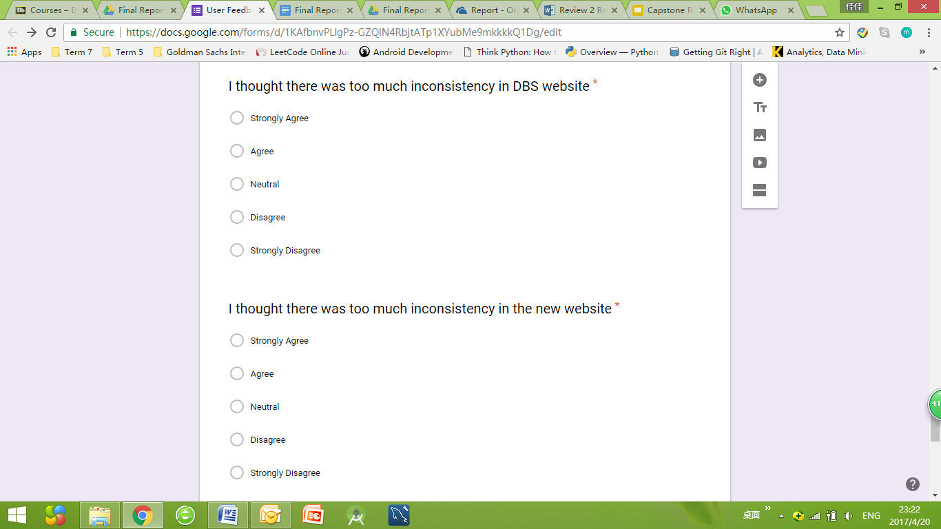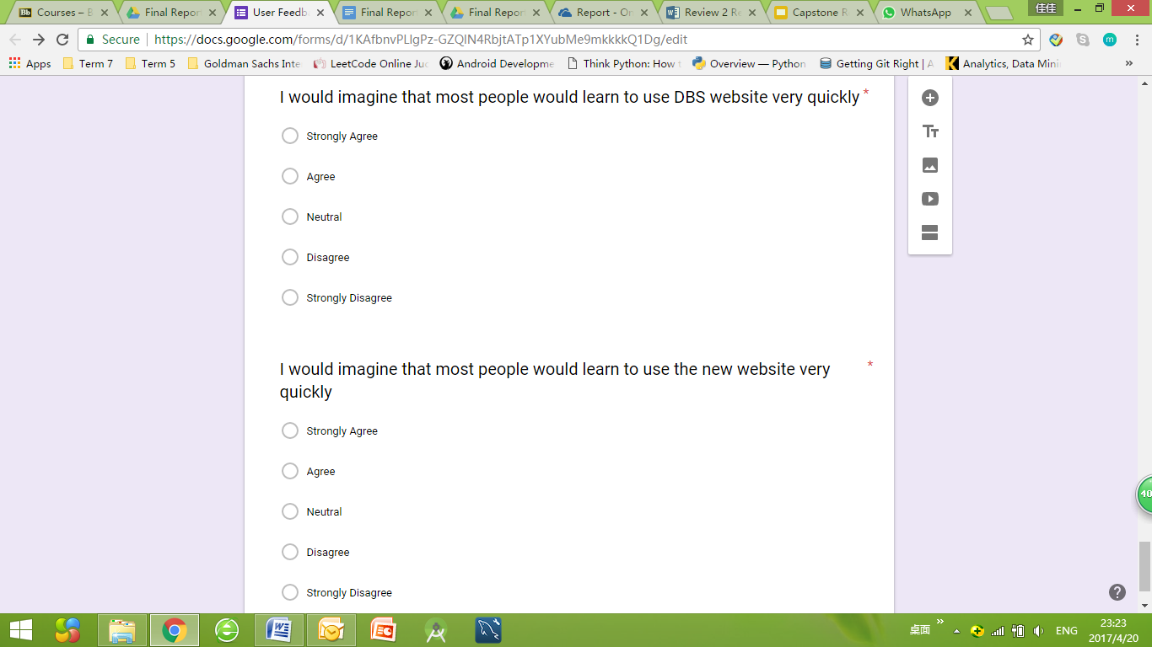

## 

## 

## Appendix E- HTML Code Used for Questionnaire Page

<!DOCTYPE **html**>

<**html lang="en"**>

<**head**>

<**style**>

**form**{

**background-color**: **transparent**;

}

**h3**{

**font-family**: **"Frutiger"**,**Arial**,**sans-serif**;

**font-size**: 25**px**;

**font-weight**: **normal**;

**color**: **rgb**(47, 46, 46);

**background-color**: **transparent**;

}

**h5**{

**font-family**: **"Frutiger"**,**Arial**,**sans-serif**;

**font-size**: 19**px**;

**font-weight**: **normal**;

**color**: **rgb**(47, 46, 46);

}

**p**{

**font-family**: **"Frutiger"**,**Arial**,**sans-serif**;

**font-size**: 23**px**;

*/*font-weight: bold;*/*

**color**: **rgb**(47, 46, 46);

}

**input**[**type**=**radio**]{

**left**: 10**px**;

**right**: 10**px**;

**top**: 10**px**;

**height**: 15**px**;

**width**: 15**px**;

**border-radius**: 100%;

**background**: **#FFFFFF**;

**transform**: **scale**(1.3);

}

**input**[**type**=**checkbox**]{

**left**: 10**px**;

**right**: 10**px**;

**top**: 10**px**;

**height**: 15**px**;

**width**: 15**px**;

**border-radius**: 100%;

**background**: **#FFFFFF**;

**transform**: **scale**(1.3);

}

**button**{

**box-shadow**: 0.00**px** 4.00**px** 0**px** 0**px rgba**(127,0,0,1);

**background-color**:**rgba**(204, 0, 0, 1);

**color**:**#FFFFFF**;

**border**: 0**px**;

**font-size**: 18**px**;

**font-weight**: **bold**;

**padding-left**: 10**px**;

**padding-right**: 10**px**

}

**button**:**hover**{

**color**: **rgba**(96, 94, 94, 1);

**background-color**:**rgba**(180, 0, 0, 1);

}

**br**{

**line-height**: 200%

}

**label**{

**font-family**: **"Frutiger"**,**Arial**,**sans-serif**;

**font-size**: 19**px**;

}

.**fixed**{

**position**:**fixed**;

**background-attachment**: **fixed**;

**top**:30%;

**left**: 57%;

**z-index**: 1;

**width**:100%;

**height**:100%;

}

.**fixed2**{

**position**:**fixed**;

**background-attachment**: **fixed**;

**top**:40%;

**left**: 52%;

**z-index**: 1;

**width**:100%;

**height**:100%;

}

.**fixed3**{

**position**:**fixed**;

**background-attachment**: **fixed**;

**top**:30%;

**left**: 80%;

**z-index**: 1;

**width**:100%;

**height**:100%;

}

</**style**>

<**title**>One Stop Center</**title**>

<**meta charset="utf-8"**>

<**meta name="viewport" content="width=device-width, initial-scale=1"**>

*<!--link rel="stylesheet" href="https://maxcdn.bootstrapcdn.com/bootstrap/3.3.7/css/bootstrap.min.css"-->*

<**script src="https://ajax.googleapis.com/ajax/libs/jquery/3.1.1/jquery.min.js"**></**script**>

<**script src="https://maxcdn.bootstrapcdn.com/bootstrap/3.3.7/js/bootstrap.min.js"**></**script**>

</**head**>

<**body onload="***invisibleImage*()**"**>

<**div class="container"**>

<**h3**>The following short 10 questions will help us provide a better filtered card information and recommendation for you. It would only take about 2 min.</**h3**>

<**h5**>The information obtained will kept confidential. To protect your confidentiality, your data will be coded. All identifiable information will be kept separate from the data.</**h5**><**br**>

<**form name="test" method="POST"**>

<**input type="radio" name="sex" value="male" id="radiomale"**><**label**>Male</**label**><**br**>

<**input type="radio" name="sex" value="female" id="radiofemale"**><**label**>Female</**label**><**br**>

<**br**><**br**><**br**><**br**><**br**><**br**><**br**><**br**><**br**>

<**p id="citizenship"**> I am a _______ </**p**>

<**input type="radio" name="citizen" id="singaporean" value="Singaporean or PR"**><**label**>Singaporean or PR</**label**><**br**>

<**input type="radio" name="citizen" id="malaysian" value="malaysian"**><**label**>Malaysian</**label**><**br**>

<**input type="radio" name="citizen" id="foreigner" value="foreigner"**><**label**>Foreigner</**label**><**br**>

<**br**><**br**><**br**><**br**><**br**><**br**><**br**><**br**><**br**>

<**p id="age"**>I am ________ years old</**p**>

<**input type="radio" name="age" id="below15" value="below15"**><**label**>15 and below</**label**><**br**>

<**input type="radio" name="age" id="16to20" value="16to20"**><**label**>16 to 20</**label**><**br**>

<**input type="radio" name="age" id="above21" value="above21"**><**label**>21 and above</**label**><**br**>

<**br**><**br**><**br**><**br**><**br**><**br**><**br**><**br**><**br**>

<**p id="employment"**>I am ________</**p**>

<**input type="radio" name="employment" id="employee" value="employee"**><**label**>Working (employee)</**label**><**br**>

<**input type="radio" name="employment" id="selfemploy" value="selfemploy"**><**label**>Working (self-employed)</**label**><**br**>

<**input type="radio" name="employment" id="study" value="study"**><**label**>Studying</**label**><**br**>

<**input type="radio" name="employment" id="otheremployment" value="otheremployment"**><**label**>Others</**label**><**br**>

<**br**><**br**><**br**><**br**><**br**><**br**><**br**><**br**><**br**>

<**p id="educationlevel"**>My highest education level is _______ </**p**>

<**input type="radio" name="age" id="university" value="below15"**><**label**>University/post-grad</**label**><**br**>

<**input type="radio" name="age" id="diploma" value="16to20"**><**label**>Diploma</**label**><**br**>

<**input type="radio" name="age" id="alevel" value="above21"**><**label**>A-level/pre-university</**label**><**br**>

<**input type="radio" name="age" id="secondary" value="above21"**><**label**>Secondary</**label**><**br**>

<**input type="radio" name="age" id="technical" value="above21"**><**label**>Technical</**label**><**br**>

<**input type="radio" name="age" id="otherEducationLevel" value="above21"**><**label**>Others</**label**><**br**>

<**br**><**br**><**br**><**br**><**br**><**br**><**br**><**br**><**br**>

<**p id="hobby"**>I like to ______ in my spare time</**p**>

<**input type="checkbox" id="shop" value="shop"**><**label**>Shopping</**label**><**br**>

<**input type="checkbox" id="din" value="din"**><**label**>Dinning</**label**><**br**>

<**input type="checkbox" id="film" value="film"**><**label**>Watching Films</**label**><**br**>

<**input type="checkbox" id="otherHobby" value="otherHobby"**><**label**>Others</**label**><**br**>

<**button type="button" id="hobbyButton"**>Next</**button**>

<**br**><**br**><**br**><**br**><**br**><**br**><**br**><**br**><**br**>

<**p id="income"**>My monthly income is around ______</**p**>

<**input type="radio" name="income" id="10above" value="below15"**><**label**>S$10k and above</**label**><**br**>

<**input type="radio" name="income" id="5to10" value="16to20"**><**label**>S$5k to S$10k</**label**><**br**>

<**input type="radio" name="income" id="2to5" value="above21"**><**label**>S$2k to S$1k</**label**><**br**>

<**input type="radio" name="income" id="below1" value="above21"**><**label**>S$1k and below</**label**><**br**>

<**br**><**br**><**br**><**br**><**br**><**br**><**br**><**br**><**br**>

<**p id="expense"**>I would want to _______</**p**>

<**input type="radio" name="expense" id="expenseWell" value="below15"**><**label**>Spend my money in advance and I am able to budget well</**label**><**br**>

<**input type="radio" name="expense" id="expenseOkay" value="16to20"**><**label**>Spend my money in advance, but I am not good at budgeting</**label**><**br**>

<**input type="radio" name="expense" id="expenseBad" value="above21"**><**label**>Spend only what I have</**label**><**br**>

<**br**><**br**><**br**><**br**><**br**><**br**><**br**><**br**><**br**>

<**p id="purpose"**>The main purpose(s) for me to apply a bank card is _______</**p**>

<**input type="checkbox" name="purpose" id="saveAccount" value="below15"**><**label**>As saving account</**label**><**br**>

<**input type="checkbox" name="purpose" id="travel" value="16to20"**><**label**>For travelling expenses</**label**><**br**>

<**input type="checkbox" name="purpose" id="work" value="above21"**><**label**>Work purposes</**label**><**br**>

<**input type="checkbox" name="purpose" id="otherPurpose" value="above21"**><**label**>Other purposes</**label**><**br**>

<**button type="button" id="purposeButton"**>Next</**button**>

<**br**><**br**><**br**><**br**><**br**><**br**><**br**><**br**><**br**>

<**p id="currentAccount"**>Do I currently have an DBS saving account?</**p**>

<**input type="radio" name="currentAccount" value="male" id="accountYes"**><**label**>Yes</**label**><**br**>

<**input type="radio" name="currentAccount" value="female" id="accountNo"**><**label**>No</**label**><**br**>

<**br**><**br**>

<**p id="specialCondition"**>Do I satisfy the following condition?</**p**>

<**input type="checkbox" name="NUS" value="NUS" id="NUS"**><**label**>I am an NUS graduates</**label**><**br**>

<**input type="checkbox" name="Army" value="Army" id="Army"**><**label**>I am current serving the Army</**label**><**br**>

<**br**><**br**>

<**h3**>Thank you for your time!</**h3**>

<**br**><**br**><**br**><**br**>

</**form**>

<**div class='fixed'** >

<**label**>Complete your persona!</**label**>

<**br**>

<**img src="https://static.wixstatic.com/media/e3b019_7d021166f0f846d792715221527c0c1e~mv2.jpg/v1/fill/w_170,h_170,al_c,q_80/e3b019_7d021166f0f846d792715221527c0c1e~mv2.jpg" alt="Male Image" width="300px" id="Male"**>

</**div**>

<**div class='fixed'** >

<**label**>Complete your persona!</**label**>

<**br**>

<**img src="https://static.wixstatic.com/media/e3b019_acfae66a1c9a4871a50cd75dcfcf6491~mv2.jpg/v1/fill/w_416,h_416,al_c,q_80/e3b019_acfae66a1c9a4871a50cd75dcfcf6491~mv2.jpg" alt="Female Image" width="300px" id="Female"**>

</**div**>

<**div class='fixed2'**>

<**img src="https://static.wixstatic.com/media/e3b019_2b5535b44e4c4305b67cc74d58b3fc82~mv2.png/v1/fill/w_512,h_512,al_c/e3b019_2b5535b44e4c4305b67cc74d58b3fc82~mv2.png" alt="Bag Image" width="110px" id="WORKING"**>

</**div**>

<**div class='fixed2'**>

<**img src="https://static.wixstatic.com/media/e3b019_b81054039abb44b3bfa4c827b2d27d33~mv2.png/v1/fill/w_256,h_256,al_c/e3b019_b81054039abb44b3bfa4c827b2d27d33~mv2.png" alt="Book Image" width="110px" id="STUDYING"**>

</**div**>

<**div class='fixed3'**>

<**img src="https://static.wixstatic.com/media/e3b019_0432bfb5af83432892e0f0163e7320a8~mv2.png/v1/fill/w_256,h_256,al_c/e3b019_0432bfb5af83432892e0f0163e7320a8~mv2.png" alt="Dinning Image" width="110px" id="DINNING"**>

<**br**>

<**img src="https://static.wixstatic.com/media/e3b019_9c8bdcf0c0b94e96b5569c47a87a9b1b~mv2.png/v1/fill/w_256,h_256,al_c/e3b019_9c8bdcf0c0b94e96b5569c47a87a9b1b~mv2.png" alt="Shopping Image" width="110px" id="SHOPPING"**>

<**br**>

<**img src="https://static.wixstatic.com/media/e3b019_a1153b4aa3524bfabf07d61b310566e7~mv2.png/v1/fill/w_600,h_600,al_c,usm_0.66_1.00_0.01/e3b019_a1153b4aa3524bfabf07d61b310566e7~mv2.png" alt="Film Image" width="110px" id="FILM"**>

</**div**>

</**div**>

</**body**>

<**script type="text/javascript"**>

**function** *setImageVisible*(id, visible) {

**var** img = document.getElementById(id);

img.**style**.**visibility** = (visible ? **'visible'** : **'hidden'**);

}

**function** *invisibleImage*(){

*setImageVisible*(**'Male'**, **false**);

*setImageVisible*(**'Female'**, **false**);

*setImageVisible*(**'WORKING'**, **false**);

*setImageVisible*(**'DINNING'**, **false**);

*setImageVisible*(**'FILM'**, **false**);

*setImageVisible*(**'STUDYING'**, **false**);

*setImageVisible*(**'SHOPPING'**, **false**);

}

$(**"#radiomale"**).click(**function**(){

$(**'html, body'**).animate({**scrollTop**:$(**'#citizenship'**).position().**top**}, **'slow'**);

*setImageVisible*(**'Male'**, **true**);

*setImageVisible*(**'Female'**, **false**);

});

$(**"#radiofemale"**).click(**function**(){

$(**'html, body'**).animate({**scrollTop**:$(**'#citizenship'**).position().**top**}, **'slow'**);

*setImageVisible*(**'Male'**, **false**);

*setImageVisible*(**'Female'**, **true**);

});

$(**"#singaporean"**).click(**function**(){

$(**'html, body'**).animate({**scrollTop**:$(**'#age'**).position().**top**}, **'slow'**);

});

$(**"#malaysian"**).click(**function**(){

$(**'html, body'**).animate({**scrollTop**:$(**'#age'**).position().**top**}, **'slow'**);

});

$(**"#foreigner"**).click(**function**(){

$(**'html, body'**).animate({**scrollTop**:$(**'#age'**).position().**top**}, **'slow'**);

});

$(**"#below15"**).click(**function**(){

$(**'html, body'**).animate({**scrollTop**:$(**'#employment'**).position().**top**}, **'slow'**);

});

$(**"#16to20"**).click(**function**(){

$(**'html, body'**).animate({**scrollTop**:$(**'#employment'**).position().**top**}, **'slow'**);

});

$(**"#above21"**).click(**function**(){

$(**'html, body'**).animate({**scrollTop**:$(**'#employment'**).position().**top**}, **'slow'**);

});

$(**"#employee"**).click(**function**(){

$(**'html, body'**).animate({**scrollTop**:$(**'#educationlevel'**).position().**top**}, **'slow'**);

*setImageVisible*(**'WORKING'**, **true**);

*setImageVisible*(**'STUDYING'**, **false**);

});

$(**"#selfemploy"**).click(**function**(){

$(**'html, body'**).animate({**scrollTop**:$(**'#educationlevel'**).position().**top**}, **'slow'**);

*setImageVisible*(**'WORKING'**, **true**);

*setImageVisible*(**'STUDYING'**, **false**);

});

$(**"#study"**).click(**function**(){

$(**'html, body'**).animate({**scrollTop**:$(**'#educationlevel'**).position().**top**}, **'slow'**);

*setImageVisible*(**'STUDYING'**, **true**);

*setImageVisible*(**'WORKING'**, **false**);

});

$(**"#otheremployment"**).click(**function**(){

$(**'html, body'**).animate({**scrollTop**:$(**'#educationlevel'**).position().**top**}, **'slow'**);

});

$(**"#university"**).click(**function**(){

$(**'html, body'**).animate({**scrollTop**:$(**'#hobby'**).position().**top**}, **'slow'**);

});

$(**"#diploma"**).click(**function**(){

$(**'html, body'**).animate({**scrollTop**:$(**'#hobby'**).position().**top**}, **'slow'**);

});

$(**"#alevel"**).click(**function**(){

$(**'html, body'**).animate({**scrollTop**:$(**'#hobby'**).position().**top**}, **'slow'**);

});

$(**"#secondary"**).click(**function**(){

$(**'html, body'**).animate({**scrollTop**:$(**'#hobby'**).position().**top**}, **'slow'**);

});

$(**"#technical"**).click(**function**(){

$(**'html, body'**).animate({**scrollTop**:$(**'#hobby'**).position().**top**}, **'slow'**);

});

$(**"#otherEducationLevel"**).click(**function**(){

$(**'html, body'**).animate({**scrollTop**:$(**'#hobby'**).position().**top**}, **'slow'**);

});

$(**"#hobbyButton"**).click(**function**(){

$(**'html, body'**).animate({**scrollTop**:$(**'#income'**).position().**top**}, **'slow'**);

});

$(**"#shop"**).click(**function**(){

*setImageVisible*(**'SHOPPING'**, **true**);

});

$(**"#din"**).click(**function**(){

*setImageVisible*(**'DINNING'**, **true**);

});

$(**"#film"**).click(**function**(){

*setImageVisible*(**'FILM'**, **true**);

});

$(**"#10above"**).click(**function**(){

$(**'html, body'**).animate({**scrollTop**:$(**'#expense'**).position().**top**}, **'slow'**);

});

$(**"#5to10"**).click(**function**(){

$(**'html, body'**).animate({**scrollTop**:$(**'#expense'**).position().**top**}, **'slow'**);

});

$(**"#2to5"**).click(**function**(){

$(**'html, body'**).animate({**scrollTop**:$(**'#expense'**).position().**top**}, **'slow'**);

});

$(**"#below1"**).click(**function**(){

$(**'html, body'**).animate({**scrollTop**:$(**'#expense'**).position().**top**}, **'slow'**);

});

$(**"#expenseWell"**).click(**function**(){

$(**'html, body'**).animate({**scrollTop**:$(**'#purpose'**).position().**top**}, **'slow'**);

});

$(**"#expenseOkay"**).click(**function**(){

$(**'html, body'**).animate({**scrollTop**:$(**'#purpose'**).position().**top**}, **'slow'**);

});

$(**"#expenseBad"**).click(**function**(){

$(**'html, body'**).animate({**scrollTop**:$(**'#purpose'**).position().**top**}, **'slow'**);

});

$(**"#purposeButton"**).click(**function**(){

$(**'html, body'**).animate({**scrollTop**:$(**'#currentAccount'**).position().**top**}, **'slow'**);

});

</**script**>

</**html**>